USDA Foreign Agricultural Service
GAIN Report

Global Agriculture Information Network
Template Version 2.09

Voluntary Report – Public Distribution
Date: 4/24/2008
GAIN Report Number: TW8027
TW0000
Taiwan
Market Development Reports
Formosa Cancer Foundation "5-a-Day" Kick-Off Press Conference
2008

Approved by:
Keith Schneller, ATO Director
American Institute in Taiwan
Prepared by:
John Halcomb, International Intern

Report Highlights:
On April 22, 2008 AIT participated in a kick-off press conference for the 2008 “5-a-Day” Campaign, sponsored by FAS’ Global Broad-based Initiative program and organized by the Formosa Cancer Foundation (FCF) and Ministry of Education (MOE). AIT’s Agriculture Trade Office (ATO) along with 13 U.S. agriculture producer associations have partnered with FCF to promote better nutrition through the daily consumption of fruits and vegetables. This will be the second year of a three year program and will include active participation of 200+ Wellcome supermarket stores. The press conference highlighted results of a recent nutritional survey conducted by FCF which discovered Taiwan school children’s favorite fruit is the apple.

AIT Spokesman Thomas Hodges said that this is a “win-win situation” for Taiwanese school children as well as U.S. fruit and vegetable producers who will also benefit from the program.

Includes PSD Changes: No
Includes Trade Matrix: No
Trade Report
Taipei ATO [TW2]
[TW]
On April 22, 2008 AIT participated in a kick-off press conference for the 2008 “5-a-Day” Campaign, sponsored by FAS’ Global Broad-based Initiative program and organized by the Formosa Cancer Foundation (FCF) and Ministry of Education (MOE). AIT’s Agriculture Trade Office (ATO) along with 13 U.S. agriculture producer associations have partnered with FCF to promote better nutrition through the daily consumption of fruits and vegetables. This will be the second year of a three year program and will include active participation of 200+ Wellcome supermarket stores. The press conference highlighted results of a recent nutritional survey conducted by FCF which discovered Taiwan school children’s favorite fruit is the apple.

The press conference was well attended, including Legislative Yuan Speaker Wang Jin-pyng, who is also chairman of FCF, Wellcome and U.S. producer association representatives, AIT and ATO staff, and more than a dozen television and print media representatives.

To begin this year’s program, a survey was conducted among 5,172 school children to determine their prior knowledge of the “5-a-Day” Program, average consumption of fruits and vegetables, knowledge of the advantages of sufficient fruit and vegetable consumption, and the schoolchildren’s favorite fruits and vegetables. While over 50% of respondents had heard of the “5-a-Day” program, 54% had inaccurate knowledge of the overall concept. The campaign focuses on educating consumers, starting with schoolchildren, on the benefits of eating 3 servings of vegetables and 2 serving of fruit each day through an interactive program using fruit and vegetable “checkbooks” with homework assignments.

The survey also showed that while nearly all of the respondents recognized the benefits of regular fruit and vegetable consumption, only 60% were in the habit of doing so. The survey also discovered that apples are the favorite fruit of Taiwan school children and pineapples were ranked 10th out of 10 fruits. Surprisingly, cabbage was one of the kids’ favorite vegetables.

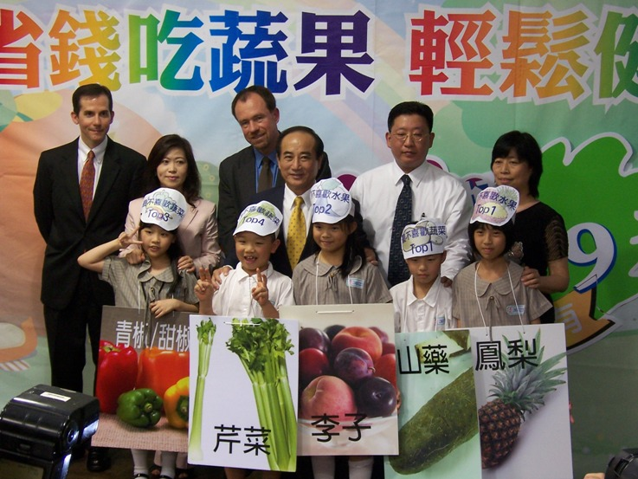
As Speaker Wang noted, “A balanced diet not only makes school children healthier, but also helps prevent cancer.”

Fuh Wei-wei, a section chief at the MOE, promised that elementary schools in Taiwan would focus on providing nutritious meals to school children, while also noting that the key to improving overall nutrition is to involve the parents, teachers, and general public.

AIT and other sponsors will provide funding and support to produce nutrition education materials that will
AIT Spokesman Thomas Hodges, Wellcome representative Piano Chia,
ATO Director Keith Schneller, Legislative Yuan Speaker Wang, COO of Yuanta
Financial Holdings Michael Ma, and Ministry of Education representative Wei-
Wei Fuh pose for a picture with Taiwanese schoolchildren to promote
2008 5-a-Day program.

be distributed to thousands of school children around Taiwan. AIT Spokesman Thomas Hodges said that this is a “win-win situation” for Taiwanese school children as well as U.S. fruit and vegetable producers who will also benefit from the program.

Wellcome supermarket chain has agreed to provide a NT$10 discount on a variety of fruits and vegetables that they sell, many of which are imported from the U.S. Fruit and vegetable “checkbooks”, each with 21 coupons, will be distributed to over 50,000 Taiwanese schoolchildren. Each coupon contains nutrition information on a different fruit or vegetable and a barcode to receive the NT$10 discount along with an interactive homework assignment which requires a parent’s signature, resulting in a system of active family education. Wellcome has agreed to share their sales data on U.S. products with ATO and producer associations in order to determine the level of success of this particular program. United Airlines will participate again in this year’s program offering two round-trip tickets to San Francisco for the lucky draw program, which will take place next November. Please find attached copy of AIT press release issued on 4/18/2008.

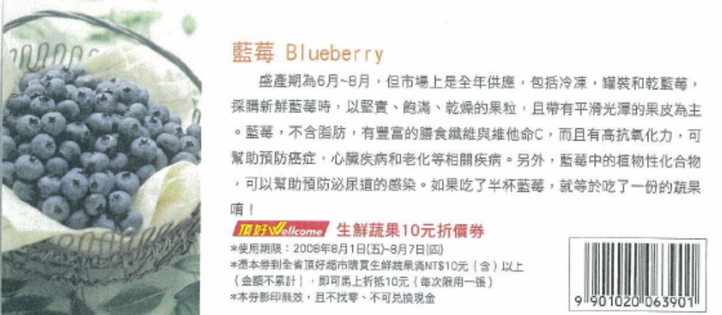
NT$10 Coupon for Blueberries

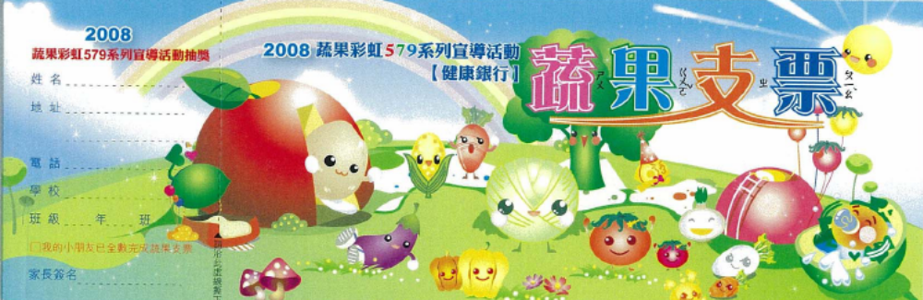
2008 Fruit & Vegetable Checkbook - Front

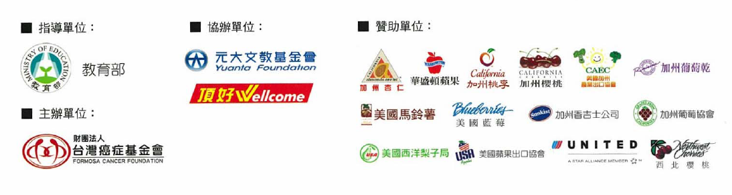
2008 Fruit & Vegetable Checkbook – Back

PR-0822 April 18, 2008

AIT AND THE FORMOSA CANCER FOUNDATION PROMOTE
BETTER NUTRITION FOR SCHOOL CHILDREN IN TAIWAN

AIT’s Agricultural Trade Office, the Formosa Cancer Foundation (FCF), and several U.S. fruit and vegetable promotion groups will hold a kick-off press conference April 22 for the 2008 “5-a-day” program. Legislative Yuan Speaker Wang Jin-pyng will provide opening remarks along with AIT Spokesman and Chief of Public Affairs Section Thomas Hodges.

In 2007, with the intention to help expand an already active nutrition promotion campaign targeting elementary school children in Taiwan and to help grow overall market demand for fresh fruit and vegetables, AIT’s Agricultural Trade Office in Taipei developed a cooperative nutrition promotion program with the Formosa Cancer Foundation (FCF) to promote the importance of eating five servings of fruit and vegetables every day. After last year’s great success and the long preparation that has gone into this year’s program, the partnership has been extended through 2008.

Funding is provided by the Foreign Agricultural Service’s Global Broad-based Initiative Program and is supported by 13 U.S. producer associations, including the California Agricultural Export Council, Washington Apple Commission, California Almond Board, California Tree Fruit Agreement, California Cherry Advisory Board, California Table Grape Commission, USA Potato Board, USA Apples, Sunkist Growers, Pear Bureau Northwest, the North American Blueberry Council, the California Raisin Marketing Board, and Northwest Cherry Growers Association.

FCF launched this program in April 2007 with a press conference announcing the results of school lunch research and continued the program with school briefings and a unique interactive program of coupon “checkbooks,” which ran through November 2007. The program reached more than 70,000 children and their families and was extremely popular with both the print and television media.

The program assisted FCF to fund new research into the nutritional profile of lunches currently prepared for students at elementary schools around Taiwan and also provided funds for FCF to train additional dieticians and to develop interactive educational materials aimed at encouraging school children and their families to improve their eating habits.

The FCF celebrated their 10th anniversary last year and received a National Civic Service award for their contributions to Taiwan society in their battle against cancer.

Taiwan’s 2008 “5-a-Day” program will be even richer than last year’s and will include a retail element through more than 200 Wellcome supermarkets across the island, where participating children and their parents will be able to receive a small discount on purchases of U.S. and other fruit and vegetables. Lucky draw prizes, including two United Airlines tickets to San Francisco, will be given away in this year’s program along with an interactive website featuring ongoing surveys regarding Taiwanese children's eating habits on the consumption of fruits and vegetables.

The press conference is scheduled 1:30 to 2:30 p.m. on April 22, 2008, at Taipei NGO House at 8, Qingdao East Road, Taipei. All members of the media are invited to the event.

For more information about the press conference and the "5-a-day" program, please contact Shirley Lai of AIT Public Affairs Section, Tel: 02-2162-2037, E-mail: slai@mail.ait.org.tw, or Hannah Wang at FCF on 02-8787-9907 ext 202.

This Press Release is also available on AIT website at:
WWW: <http://www.ait.org.tw/en/news/pressrelease/

