USDA Foreign Agricultural Service
GAIN Report

Global Agriculture Information Network
Template Version 2.09

Voluntary Report – public distribution
Date: 6/28/2007
GAIN Report Number: CH7608
CH7608
China, Peoples Republic of
Market Development Reports
Sanya: China's Tropical Paradise
2007

Approved by:
Joani Dong
US ATO Consulate Guangzhou
Prepared by:
May LIU

Report Highlights:
Sanya's tourism benefited from growth of China's economy and governmental support. It is often touted as "China's Hawaii" for its tropical climate, fine, sandy beaches and year-round sunshine, but not for cuisine. Sanya's visitors mostly consist of Chinese from other cities, not foreigners with western tastes and pocketbook to match, as in Phuket, Thailand, another tropical paradise. To understand the market, post interviewed senior restaurant execs, hotel managers and local government officals. Overall, many believe promoting American foods at this time might be premature with the possible exception of beef(when officially available), wines and selected U.S. fruits for gift giving at five star hotels. Some guardedly believe that western foods and therefore U.S. products could have prospects within five to eight years, given increasing build-up in existing tourist areas as well as construction of Haitang Bay, a new five star resort area 20 km west of Sanya.

Includes PSD Changes: No
Includes Trade Matrix: No
Unscheduled Report
Guangzhou [CH3]
[CH]

Sanya Overview

Located in the South China Sea between Guangdong province and Vietnam, is the island of Hainan. Sanya lies in the south and occupies 740.7 square miles and a coastline of 130.5 miles. By the end of 2005, Sanya’s official population reached 524,000 with GDP per capita of US$1,192. Sanya boasts marine, mineral and water resources. As a result, Sanya benefits from central and local government initiatives aimed at developing the island's vast potential for tourism. Sanya’s tropical climate helps boost production of vegetables, fruits and other tropical crops such as flowers and seeds. Sanya’s climate is conducive for cultivation of its marine industry. The products are mainly sold to mainland cities and exported to Hong Kong, Japan, Korea and Taiwan. Sanya has what it takes to make it a tourist draw—warm weather, long white beaches, but it is still in its infancy when it comes to importing U.S. food products.
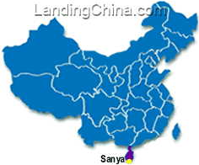
Sanya is at the southernmost tip of South China

Tourism has been an important source of revenue for Sanya in recent years. For example, in 2005, tourism generated US$ 0.6 billion, up 30 percent from 2004. In addition, Sanya’s hotels officially welcomed 4.1 million overnight tourists (including 230,000 foreigners) in 2005. During the first ten months in 2006, up to the day of our interviews with the Sanya Tourism Bureau, the growth in the tourism sector was over 12 percent compared with the previous year.

It’s not surprising, then, that in the past five years, the Sanya government invested more than US$1.96 billion in building tourism-related infrastructure including roads, a modern sewage system, international cruise ship passenger docks, sight-seeing areas, hotels and resorts. In addition, the city government promotes its traditional culture of Li, Miao and Hui as a tourist draw.
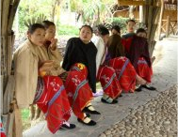
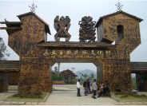
Minority village for tourists

A major government project is the new Sanya Phoenix International Airport built to international standards to accommodate large aircraft such as Boeing 747s. A second phase of the airport project is underway. Upon completion, this airport will handle up to 6 million passengers a year.

The Sanya government promotes an Exit-Entry Group arrival visa policy to lure more international tourists. For those tour groups consisting of a minimum of five people who come from countries such as Japan, Singapore, Malaysia, Thailand, Korea, the Philippines, Indonesia, Germany, Great Britain, France, Austria, Italy, Russia, Switzerland, Sweden, Spain, Holland, the United States, Canada, Australia, New Zealand and are holding valid passports, they can simply apply for a tourist visa upon arrival at Sanya airport. This visa is also valid for visiting other cities in China after the visitors’ Sanya tour.

The growing travel industry fuels Sanya’s tourism. Already there are direct flights to Sanya from Hong Kong and chartered flights from St. Petersburg and Moscow. Russian Continental Airlines increased chartered flights between Moscow and Sanya from three to seven per month, thereby increasing the number of guests flying directly from Russia to Sanya. China Southern Airlines has opened daily flights between Urumuqi (in western China) and Sanya, thereby increasing visitors from central Asia. From May to October of 2007, the British MyTravel Airways will begin flying from Manchester or Gatwick directly to Sanya. Flights will be on a bi-weekly schedule. Last year Shanghai-based Spring International Travel Service opened an office in Sanya for Spring Airlines and plans to add 15 planes by 2010. They expect to increase current aviation business revenue in Hainan to as much as US$75 million in 2007. The world’s top passenger liner, Italian Costa Crociere S.P.A., in November 2006 initiated a fixed seaway to Sanya. The liner will visit Sanya at least 6 times a month. Costa Allegra will cruise on the scheduled line of “ Hong Kong – Sanya – HaLong Bay – Hong Kong”. China Ocean Deluxe Cruises is also developing deluxe cruise travel services in Hainan. They first launched their ship, Mona Lisa, in 2006 and will launch another ship by the end of 2007. This will allow them to cruise among Sanya, the Philippines, Hong Kong, Thailand, Malaysia, and Brunei.
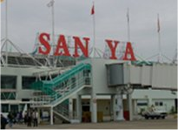
Sanya Phoenix Airport is primarily the destination for Chinese, European, Russian, Korean and Japanese tourists.

Sanya at a glance – 2005

Area: | 740.7 square miles
Coastline: | 130.5 miles includes Yalong Bay, Sanya Bay, Dadonghai and Haitang Bay
Population: | 524,000 represent 20 ethnic nationalities, for example, Li, Miao and Hui. Main language is Putonghu. English is spoken at all first class hotels.
GDP | US$ 9.8 billion, GDP per capita US$1,192
Tourists over night: (person) | 4.1 million, of which 230,000 were from outside China according to official statistics
Tax Revenue | US$91.4 million, up 22.4% from 2004
Total retail sales | US$0.3 billion, up 13.1% from 2004
Total foreign trade (Imp + Exp) | US$216.1 million, at 10.6% annual growth rate
Major Agriculture Products outputs: | 414 tons of melons and vegetables, 200,000 tons of fruit, 81,000 tons of aquatic products. Profits from agriculture increased US$ 263.1 million (RMB 2,105 million) in 2005. They are mainly sold to mainland cities and to Hong Kong as well as exported to Japan, Korea and Taiwan.
Climate: | Tropical marine climate. An average of about 12 hours a day of daylight and more than 300 days a year, on average, are sunny.
Climate: | Jan | Feb | Mar | Apr | May | Jun | Jul | Aug | Sep | Oct | Nov | Dec
Climate: | 20.9 | 21.9 | 24.1 | 26.4 | 28.2 | 28.5 | 28.4 | 27.9 | 27.2 | 25.9 | 24 | 22

Source: Statistics from Post’s interviews with Sanya Government officials, 2006

The hotel and restaurant sector is booming, but limited demand for western foods is at the restaurants of five star hotels
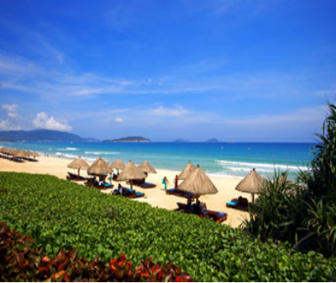Ocean view from Sheraton Sanya- Yalong Bay

With Sanya government’s support of tourism, the hotel sector has grown dramatically. The Hoteliers Association frequently organizes forums to provide dialogue between the Sanya government and hotels. The local government also works closely with five star hotels to promote Sanya throughout Asia, with plans to promote Sanya globally.

However, when it comes to whether a hotel will consider using imported food, one hotel manager stated “only if a the charge for an hotel room exceeded $92 (700 RMB) per night.” One F&B manager stated that food costs were higher in Sanya relative to other cities due to required air transport of selected items which makes margins slim and the use of imports less likely.

Sanya is a relatively new tourist destination to many Chinese which make up 60 percent of total visitors (refer to Appendix 1 – Profile of the Typical Tourist in Sanya). The recent development of Sanya as China’s only southern tourist destination creates keen competition for northern holiday destinations such as Qingdao and Dalian. Sanya, which didn’t boast a single international hotel in the past decade, now has 15 five star hotels and 30 four star hotels. There are also about 120 three star hotels.

In addition to attracting tourists from China, Sanya has great potential in attracting overseas tourists. This is evident in the increasing number of international flights into Sanya. In recent years, foreign tourists from Europe, i.e., England, Germany, France and Scandinavia, have been increasing, but they tend to visit other parts of China as well so Sanya represents a two to four day stay for Europeans which make up 20 percent of total visitors. Tourists from Russia and the former Soviet Republic make up 10 percent of total visitors who tend to stay for two weeks to enjoy the warm weather and sandy beeches. Many hotel managers estimate there will be a boom in tourists from these countries, and hopefully from Japan. Visiors from other Asian countries represent 10-15 percent. Many of the tourists who come to Sanya enjoy beach sports such as diving and swimming. Other attractions include scenic spots such as hot springs, small nearby islands known for their beaches and caves, and scenic spots such as “End of the World”. Dadonghai Bay offers diving during the day and nightlife along Dadonghai beach, home of seafood restaurants and beachside bars. In addition, Sanya has a growing reputation as a golfing paradise, with two in the city and four under construction. The trade believes ten will be needed within a decade.

Food preferences among these tourist groups differ in Hainan Island. Tourists from China and other Asian countries prefer Chinese food or Asian food. Therefore, their preference for western food is not as strong as that of expatriates who live in Sanya and that of western tourists. For the nouveau-rich Chinese and Asian tourists such as Japanese and Korean businessmen who stay in top hotels in Yalong Bay, western food prices are not deciding factors as much as familiarity. For example, many Japanese and Korean businessmen visit Sanya regularly with golfing in mind. Just like many Chinese, they are more fond of oriental dishes than western dishes. For the Chinese and Russian who stay in mid-class hotels, they patronize budget restaurants, therefore the price of the meal is as important as type. Russians come in groups on chartered flights. They may try Chinese food, i.e., local seafood or local “western food”, but prefer Russian food in Russian restaurants in Dadonghai Bay. Hotels where U.S. products should be promoted is at the five star hotels with clients that can afford them.

Recently, many Sanya hotels in Yalong Bay target business visitors who normally stay two to four days by promoting Sanya and hotel service as an ideal destination for meetings, conventions, exhibitions and weddings. These hotels focus on attracting commercial tourists from major cities in China, other Asian countries and Europe.

Most of Sanya’s hotels are in Yalong Bay, Dadonghai Bay and Sanya Bay. Some of them are in Sanya proper. In addition to these developed resort areas, Haitang Bay will be developed within five to eight years and include hotels, hospitals and schools according to Sanya government sources. Haitang Bay is about 30 minutes west of Sanya. Seven corporations have been approved to build international holiday resorts in Haitang Bay to attract more tourists.

- Yalong Bay, 15.5 miles east of Sanya, and about 30 minutes from the downtown area, is considered the most beautiful bay area and, therefore, the most popular tourist destination in Sanya. The Yalong Bay National Holiday Resort area is where over ten first class five star hotels are located. The first Chinese five-star hotel in Yalong Bay,

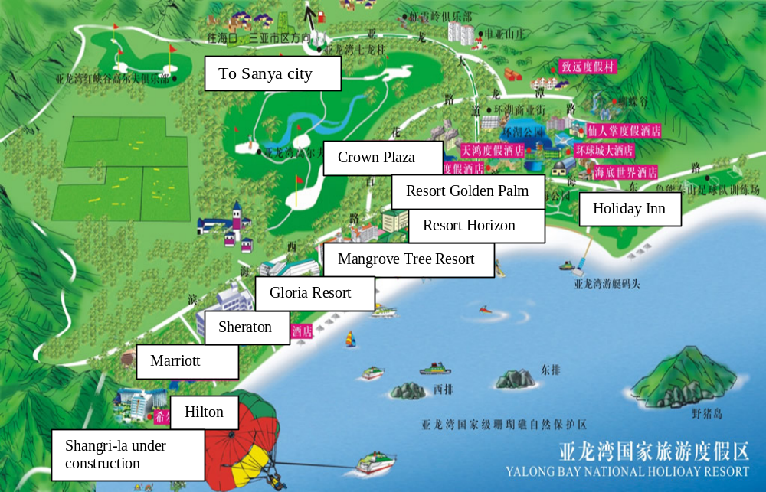
International hotels are concentrated along Yalong Bay.

is the Gloria Resort built in 1996 and located at the center of Yalong Bay with the best ocean views. Following on the heels of the Gloria, top international hotels set up shop in rapid succession, i.e., the Sheraton (2002), Marriott (2004), Hilton (2005), Mandarin Oriental and Holiday Inn are all in Yalong Bay.

- Dadonghai Bay is south of Yalong Bay and west of Sanya. It takes 10-15 minutes by car to the downtown area from Dadonghai Bay. There are over 50 locally owned and operated hotels in Dadonghai Bay, catering mostly to many Chinese family and Russian tour groups. There is a diving base in Dadonghai Bay. In addition, nightlife along Dadonghai beach is also quite dynamic. Most of the action is on Yuhai Lu, where there are rows of seafood restaurants and beachside bars. Chinese seafood and Hainan specialties are the dishes most commonly ordered.
- Sanya Bay is still developing. It is in the west of the city and has a 9.3-mile stretch of white sandy beach, catering to mostly to Chinese groups on cheap package tours. There were almost no international hotels in Sanya Bay until this past January when the five star Kempinski Hotel was opened, probably because there is no open space left in Yalong Bay. Post believes that when Kempinsiki Hotel opens in Sanya Bay, the government will focus on the developing Sanya Bay.

The hotel boom in Sanya has increased demand for experienced staff, especially those who have worked in the service sector and who can speak English. Top international hotels in Yalong Bay lure the most talented employees.

Within five years, increasing numbers of Chinese will gain exposure to western culture, and awareness towards western cuisine will also increase as well as demand.

Where visitors and locals dine (outside of hotels)
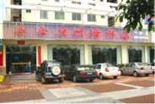
A local seafood restaurant

The Chinese restaurant sector in Sanya is expanding. In addition to restaurants in the five star hotels in Yalong Bay, Sanya boasts many local seafood restaurants in the Dadonghai Bay and Sanya Bay area. Thanks to abundant seafood resources in the surrounding South China Sea, these local restaurants serve many fresh dishes. Tourists can also enjoy inexpensive seafood on the floating restaurants near Sanya’s fishery area.
Because there is so much variety of Chinese foods in Sanya, interest in western food is overshadowed. One reason is due to the lack of proper promotion of western foods. Another is that local restaurants do not serve true western foods and are only available at international hotel restaurants. Post visited over ten ‘mid- to high- level “western restaurants” in Sanya (that weren’t in hotels) and only one was authentic. In addition, only a few restaurants offered menus in English or with pictures to illustrate dishes. Service was poor. Post also observed that the wait staffs could not speak English. As for Western fast foods restaurants, there was one McDonald’s and one KFC downtown. This strongly indicates that Sanya is still in its infancy when it comes to western foods.

Major constraints for U.S. foods

- Limited familiarity with western cuisine
- Keen competition
- Price sensitivity
- Limited availability
- Lack of adequate promotion
- Lack of distinct identity
- Limited import networks

Most local residents prefer only local Chinese foods because of its affordability and familiarity. Unlike in Guangdong or Fujian province, they are not familiar with imported foods, in particular, with western foods. Even if they were familiar, they cannot always afford them.
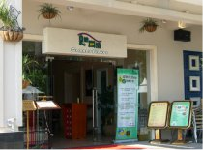A local western-style restaurant

In light of limited opportunities for western food in local restaurants, post recommends that U.S. food exporters focus on selected high-end hotels, i.e., in Yalong Bay, if they want to promote products. However, U.S. exporters will encounter several challenges. For example, post learned that most of the five star hotels use locally produced food and ingredients due to lower cost and under-developed import networks for U.S. food items. For example, there are few importers in Sanya. Therefore most imported food items are brought into the city via Haikou (in northern Hainan) from Guangzhou or Shanghai. It is difficult for most U.S. food products to compete with Chinese domestic products on price and availability.

The one U.S. product that could be the most promising in terms of promotion is U.S. beef, which contacts spoke enthusiastically about. Although U.S. beef has not been officially available in China, there is optimism among those interviewed that U.S. beef will be in great demand once the market is reopened. In fact, many F&B managers in these hotels admitted that they are now using Australian beef but would be very interested in promoting U.S. beef.
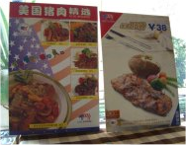
U.S. pork promotion at a cafe in downtown Sanya

Unlike U.S. beef, U.S. pork is available in high-end hotels and in some western restaurants, but the price is generally too high compared with local pork or Mongolian pork. One western restaurant tried to differentiate itself from competitors by promoting U.S. pork in Sanya but discovered that most of its customers preferred the cheap local dark pork and couldn’t really tell the difference

Sanya is a competitive market for U.S. fruits and seafood products. For example, Red Delicious apples, Sunkist oranges, and California Red Globes and table grapes are found in high-end hotel restaurants as gifts in special VIP hotel rooms. However the imported fruits meet keen competition from local tropical fruits because supply is plentiful, the cost is lower, and the distribution is easier. In addition, it is hard for imported seafood to compete with local seafood.
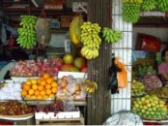
Colorful fruit display in local produce market

Another challenge to the import of U.S. seafood is the growing market share dominated by other western countries. For example, the Norwegian government each year invests substantially in promoting their seafood products. From August to September, Norway selects 15 cities in China in which to promote Norwegian salmon. They bring chefs from Beijing to Sanya and invite Food and Beverage Managers to participate in a cooking seminar and learn new ways to promote Norwegian salmon in their hotels. Post interviewed several Sanya’s five-star hotels; they felt these educational events were worthwhile.
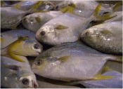
Local catch at the fish market

U.S. wines, known in Sanya for high quality and reasonable prices, have presence in some high-end hotel restaurants. However, wines from France and Australia gain more market share because they are more aggressively promoted (i.e., tastings, discounts, gifts of wine, etc.) by wine traders and Sanya hotels and restaurants. Therefore, it is essential for U.S. wine companies to build good relationships with the F&B managers at Sanya’s five star hotels and restaurants as well as with local wine and hotelier associations. ASC Fine Wine Company has sent a special team to work closely with these hotels and restaurants in Sanya.

Post was informed that the hotels in Sanya always work individually. This is another obstacle to promoting U.S. food products. However, more hotel managers want to change this practice to reduce cost. Therefore, recently, the Hilton, the Sheraton and the Resort Intime hotels worked together to place a substantial order for turkeys. It is estimated that in the near future, these hotels will place more similar joint-purchases.

Retail sales of U.S. food is limited

Retail commerce in Sanya is just beginning. Apparently, foreign retail giants showed little interest in Sanya due to small market size, as Hainan’s total retail sales of US$2.5 billion per year are the lowest among the nine Pan-PRD provinces. Most importantly, local residents’ low incomes limit purchasing power. The major retailers in Sanya are locally owned. They are Summer Mall, Pearl Plaza, YiFang Shopping Center, all located in downtown area.

There are two major obstacles to the promotion of U.S. products in local retailers. The first is the lack of demand for western food items. The second is the lack of sufficient promotion skills in these local retailers. For example, upon a visit to these local retailers, one can find almost no imported items available on shelves; the products are poorly displayed; there is no promotional atmosphere, etc. However post found a large display of “Dove” chocolates in one local supermarket called “Wanghao”. Although all were produced in Mainland China, this observation indicates that there is demand for chocolate, which is a new product for the Chinese. Post assumes customers who buy these chocolates are foreigners, tourists from other mainland cities as well as local Sanya residents. However, based on all the above-mentioned observations, post concludes that may not be the right time for U.S. food exporters to position their market in Sanya.

As most five star hotels are in isolated bay areas, such as Yalong Bay, tourists at these hotels have to take a 20-30 minute drive to downtown Sanya for grocery items or to shop in local department stores. They will not find many western food items otherwise common in bigger cities. Some hotel managers are considering building large retail shopping facilities within hotel areas. Post believes that within five years, many new-concept resorts that combine hotel and retail space will be introduced to Sanya.

Summary

Currently, the most promising sector for U.S. food is in the five star hotel restaurant sector. Sources believe U.S. beef is the most promising item, while wines and fruits have a niche. However, post repeatedly heard that wine was not adequately promoted. With more new hotels and restaurants being built in Sanya as well as construction of Haitang Bay in five to eight years, more tourists from around the world with disposable income will visit Sanya, the beautiful tropical paradise, and demand for western food will increase.

--------------------------------------------------------------------------------------------------------------------------------------------
This article was written by May Liu, Agricultural Marketing Specialist, for ATO Guangzhou. She may be reached for comment at May.Liu@usda.gov

Appendix: Table 1 - Profile of Typical Tourist in Sanya

 | Profile of Typical Tourist
 | Chinese (Middle-class family, businessmen, visitors from Hong Kong, Macau & Taiwan) |  | Other Asian countries (Japan, Korea) |  | Russian | Other western Visitors
Length of stay | 2-3 days on business trip | Long week on vacation | One week |  | Two weeks to one month | 3-4 days on route to other cities
Social status or background | Businessmen governmental officials &  managers | Middle-class family from big cities like GD, Fujian, Shanghai, Beijing, Chengdu | Businessmen,  golfers |  | Businessmen, family,
Travel frequency | Every so often | Once or twice a year | Every so often |  | Mainly in winter
When to visit | Year round | Spring Festival, May Labor’s day, October National day holidays | Year round |  | Winter
Reason for travel | Business meeting | Family gathering & tourism | Golf, business meeting |  | Enjoy warm weather
Favorite food | Chinese seafood (fresh & hot pot), Hainan specialties and spicy food |  | Japanese food, Chinese seafood | Korean food, Chinese seafood | Soup, salad, Chinese seafood |  | Western food and Chinese seafood
Where they stay | 5-star hotels in Yalong Bay | 3 star hotels in Dadonghai or Sanya Bay | 5 star hotels in Yalong Bay |  | Yalong Bay, Sanya Bay, or Da Dong Hai Bay (hotels vary from 3 to 5 star)
Where they dine | Hotel restaurants, high-end Chinese restaurants | Local Chinese Restaurants at cheap prices | Hotel restaurant, restaurants in downtown area |  | Restaurants in downtown area, Western style
Hobbies & favorite activities | Hiking, diving, golfing | Swimming, sightseeing, hiking | Golfing |  | Swimming, sightseeing
Average tourist % | 60%-70% |  | 10%-15% |  | 25%-30%

Source: ATO/ GZ’s visits and information provided by Sanya Hotels and Restaurants. Percentage of tourists vary by different season

Appendix: Table 2 - Hotels carrying U.S. wines in Sanya in 2006

Hotel Name | Rating | Area
Gloria Resort | 5 star | Yalong Bay
Holiday Inn Resort | 5 star | Yalong Bay
Sanya Marriott Resort & Spa | 5 star | Yalong Bay
Sheraton Sanya | 5 star | Yalong Bay
Hilton Resort & Spa | 5 star | Yalong Bay
Resort Horizon | 5 star | Yalong Bay
Mandarin Oriental | 5 star | Yalong Bay
Crown Plaza | 5 star | Yalong Bay
Mangrove | 5 star | Yalong Bay
Rendezvous Baohong Hotel | 5 star | Dadonghai Bay
Resort Intime | 5 star | Dadonghai Bay
Kempinski Resort & Spa | 5 star | Sanya Bay

Source: ATO/GZ’s visit, information provided by ASC wine company

Appendix: Table 3 - Activities in Sanya

Sanya is alive and kicking the year round with festivals and gala events

International Coconut Festival and Li and Miao Festival | 3rd day of the 3rd moon of the lunar year (March 3) | The Li and Miao nationalities celebrate life and love with traditional dance and food.
International Labor Day | May 1 | Celebration honoring workers of every nationality.
Duanwu Festival Dragon Boat Festival | 5th day of the 5thmoon of the lunar year (May 5) | Dragon Boat enthusiasts gather to pit their skills and strength against each other and the sea.
Mid-autumn Carnival at the Remotest Corner of the Earth Resort (Tianya Haijiao). | 15th day of the 8th moon of the lunar year | Sponsored by the Sanya Tourism Investment Co Ltd.
Double Ninth Festival on Nanshan Cultural Tourism Zone | 9th day of the 9th moon of the lunar year (September 9) | Sponsored by the Tourism Bureau of Nanshan in celebration of longevity.
International Wedding Festival at the Remotest Corner of the Earth Resort (Tianya Haijiao). | November 18 | Newlyweds and long-married couples celebrate their vows on the beach.

Appendix: Table 4 - Recommended Restaurants in Sanya

Restaurant Name | Area | Additional Information
Dongjiaoyelin | Dadonghai | English menu for local seafood
Ai Wanting | Dadonghai | English menu for Hunan spicy food and seafood
Chatter Box Café | Dadonghai | English menu
Rainbow Café | Dadonghai | English menu
Dongbeiren Noodles and Dumplings | Dadonghai | No English Menu
Bai Guo Bu Yi | Downtown | Spicy Food with pictures, no English menu
Versailles Restaurant & KTV | Downtown | English Menu, Asian/ Western Food
Essence of Europe | Downtown | English Menu, Western Food
Haiya Local Food | Downtown | No English menu, no pictures, local seafood
Times Café | Downtown | English menu, western style
Liguo local | Downtown | No English Menu, no pictures
Yuan Xing Long local food | Downtown | No English Menu, but with some pictures
Mediterranean Restaurant | Downtown | English Menu. Good decoration, good price, offering Italian Pizza
Armando Barbecue Buffet | Downtown | Brazil BBQ
Winner Pizza | Downtown | English Menu
McDonald | Downtown | Fast Food
KFC | Downtown | Fast Food
IZE for seafood and fine wines in Hilton Resort | Yalong Bay | English Menu
Pastry/Korea Cuisine | Yalong Bay | English Menu
Thai Restaurant in Mangrove Tree Resort | Yalong Bay | English Menu

Source: ATO’s visit and information provided by www.sunnysanya.com

