USDA Foreign Agricultural Service
GAIN Report

Global Agriculture Information Network
Template Version 2.09

Voluntary Report - Public distribution
Date: 8/16/2007
GAIN Report Number: CH7816
CH7816
China, Peoples Republic of
Market Development Reports
Suzhou: An Emerging City Market in the Yangtze River Delta
2007

Approved by:
Wayne Batwin
U.S. Consulate
Prepared by:
Katherine Hanson and Sarah Wegmueller

Report Highlights:
Considered the ideal weekend getaway place for Shanghainese, peaceful and secluded, Suzhou has long been regarded as Shanghai’s backyard. Today, with 113 Fortune 500 companies infusing their investment dollars into this historic tourist city, Suzhou has become the leading economic player and major international force of the entire Yangtze Delta (YRD) region. Suzhou is not the backyard anymore; it is second only to Shanghai in economic importance in the YRD, and has been named by Forbes as the 6th best commercial city in all of China.

Includes PSD Changes: No
Includes Trade Matrix: No
Annual Report
Shanghai ATO [CH2]
[CH]
City Profile

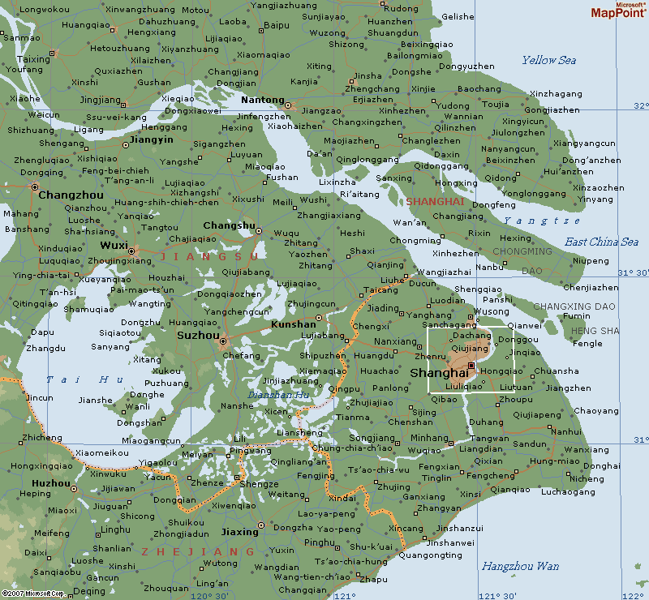
Regarded as the backyard of Shanghai, Suzhou is a well-known tourist destination and cultural city, as well as a coastal economic opening area. Famed as the “Oriental Venice”, along with a history of more than 2,500 years, it presents a multitude of attractive scenic sites. “Xiao-qiao, Liu-shui, Ren-jia” (“small bridges, running water, old traditional houses”) is a perfect description of Suzhou, drawing a picture of old-fashioned houses and delicate bridges arching over flowing waters.

Shanghai on the east, Zhejiang Province on the south, Taihu to the west and the Yangtze River to the north. Suzhou is extending its influence in every direction.

With its surrounding towns and smaller cities such as Kunshan, Wujiang and Changshu, the entire Suzhou municipality can be considered as one economic unit.

Suzhou is situated in the south of Jiangsu Province, in the middle of the Yangtze Delta. It is bordered on the east by Shanghai, Zhejiang Province on the south, Taihu to the west and the Yangtze River to the north. Suzhou enjoys a mild and humid climate.

A network of national highways, railway lines, and water routes converge in the city, making it an excellent distribution hub for regional markets. Located about 100 km from Shanghai, it is only about a 40 minute express train ride away. Trains run in both directions every 20 minutes from Shanghai and Suzhou. A shuttle bus comes to Shanghai Pudong airport and Shanghai Hongqiao airport almost on an hourly basis, taking about 2 hours and 1 hour 40 minutes one way to each of the airports respectively. The well-developed water transportation system includes the Yangtze River, Lake Taihu and the Beijing-Hangzhou Grand Canal.

Suzhou is one of China’s wealthiest cities in the Yangtze River Delta area and even all of China. As the largest economy in Jiangsu Province, Suzhou’s GDP accounts for 19.6% of the province’s total GDP. The city has taken two major strategic directions: to build the city as the “leading destination of FDI” (foreign direct investment), and to become the “base for new and high-tech industries.” Suzhou has become an externally oriented economy. Foreign investment and international trade are playing an increasingly important role in its economic development. At the end of 2006, 113 Fortune 500 companies had established a presence in Suzhou. These companies are scattered in the 5 state level economic development zones, namely Suzhou Industrial Park, Suzhou Hi-tech Development Zone, Kunshan Hi-tech Development Zone, Zhangjiagang Bonded Zone, and Taihu State Tourist and Resort Development Zone.
Yangtze River Delta
Suzhou At a Glance (2006)
Population | 6.16 million
GDP | $53 billion
GDP/Capita | $8,148
Disposable Income per capita | $2,439
Expenditure per capita | $1,641
Major Food Retailers | Metro, Carrefour, RT-Mart, Auchan, Lotus, Hualian, Huarun, Kedi
Major Industries | Electronics, IT, electrical machinery, bio-technology and medicine, chemicals and household electrical appliances
Key Agricultural Products | Hairy crab, freshwater fish, silk, pork, dairy, poultry, vegetables
Source: Suzhou Statistical Yearbook, 2007
Sector Analysis

Hotels & Restaurants

Hotels and restaurants are a very important part of Suzhou’s commercial activity, accounting for 10% of the total commercial industry income. Presently there are many opportunities for food exporters. From French fries to “authentic American steak”, one can find imported goods at almost every conceivable level. Authentic western-style food has a remarkable market in Suzhou, driven by the large number of expatriates who work there and their influence on local Chinese.

Suzhou’s hotel sector continues to expand rapidly. It has always been a city famous for tourism, so historically there has been a great demand for quality hotels. With over 20% of the Fortune 500 companies having set their stakes in Suzhou, more and more international conferences are being held there. Higher quality lodging is also in great demand; 27 new hotels were added just in 2006, making 134 hotels in total. Among them are 37 four-star or five-star hotels.

Impact of Tourism
 | 2006 | % increase from 2005
Number of domestic tourists (million) | 41.4 | 13.0
Income generated from domestic tourists (US$million) | 6,159 | 21.5
Number of international tourists (million) | 1.8 | 16.3
Income generated from int’l tourists (US$million) | 748 | 17.0
Source: Suzhou Statistical Yearbook, 2007

Suzhou’s highest-end restaurants are located in four or five star hotels. They favor western style cuisines, which makes the hotel industry an ideal entry point for new-to-market imported food ingredients. Local restaurants then follow their lead and further help stimulate the consumption of imported food.

The two chefs ATO Shanghai interviewed from the Shangri-la and Sheraton hotels both have a very strong preference for imported products. They expressed the need to be introduced to a greater variety of imported food products other than the ones that are available to them through their distributors. They even showed interest in finding someone who could supply them everything that is available in the foreign market, so they can choose freely, bypassing the limitation of the local distributor’s knowledge of available products. The chef in the Shangri-la hotel has recognized the demand for imported food products from his local customers. He has sponsored many foreign food product shows, including Italian, Thai and Malaysian. This year he is planning an American barbeque cooking show in November to honor the American Thanksgiving holiday, during which he will introduce new dining ideas to his customers.

An owner of a local distributor-Eurofood-just returned from the United States. He stated that the trip truly opened his eyes, and he thinks many American food products would have a very good market in Suzhou. His goal is to be the first one to introduce some unique American products to Suzhou consumers. With more than 10 years service in the Suzhou area, and being the leading local distributor, he knows the market for high-end imported products is huge for such products as wine, beef, fresh fruit, breakfast cereal, coffee and some condiments. ATO staff was amazed to learn that this distributor has his own temperature-controlled warehouse and delivery truck, which to our knowledge is the first cold chain that is owned and used by a distributor in Suzhou.

Retail

Like supermarkets anywhere else in big cities throughout China, several retail chain stores-Auchan, Carrefour, RT-Mart, Lotus- show their success in Suzhou in many ways. They offer broad lines of products, and they are always crowded with customers. In all the stores there is a separate aisle labeled “Imported Goods” but we noted there were fewer goods from America than from other countries. Nanpu Food, another food distributor in Suzhou, stressed the huge market in Suzhou for imported wines. The ones priced at 700-800 Yuan per bottle are recognized as excellent gifts for holidays, while those costing 50-400 Yuan are consumed widely in households. Some of the supermarkets in Suzhou have more than 10% of their total SKUs now in imported products, and the projected percentage is expected to rapidly increase in the next few years and could reach nearly 40% by 2010.

Metro is a wholesale cash and carry retailer, and has its niche in the market. It is much like Sam’s Club in America, where customers are limited to members only. Most of these members are small businesses like cafeterias, schools, factory canteens, and small local restaurants. Individuals are not the key targets for Metro, but there are still a few who shop there. Most of these individuals are high-income earners or foreign expatriates. ATO observed that the store is cleaner, less crowded, offers larger packages, and higher quality than other retail outlets, yet it still maintains the necessary variety to satisfy different customers' needs. The GM of this Suzhou Metro did not show any concern over competition from other supermarkets. He believes that his customers in Suzhou have a much greater capacity to purchase higher priced products. These customers are willing to pay higher prices to shop in a more convenient and cleaner environment. Product availability is their basic requirement; they want “one stop shopping” where they can come to one store and be able to purchase everything they need. The number of Metro’s members has reached 130,000 in just one year since its opening. American canned vegetables and fruit, spaghetti sauce, coffee and fresh fruits sell very well here.
Source: Jiangsu Statistical Yearbook, 2006

Most hypermarkets use Shanghai as a central buying and distribution center for imported items. The cold chain between Suzhou and Shanghai is well developed, and distributors are usually responsible for arranging delivery of the items.

Small convenience chain stores, like Lianhua and Kedi, can be found on almost every street. Small packaged, snack style imported products are their primary stock items. Individual purchases may be small, but sales are constant. In the first half of 2007 alone, there were 29 new stores added to the total.

Suzhou has two pedestrian malls known as Guanqian Street and Shilu Center, with a third one being built near Nan Men. Guanqianjie is just like Nanjing East Road in Shanghai. They have become another attraction for tourists as well as local residents, and present a marketing opportunity to a captive audience.

As mentioned previously, the uniqueness of Suzhou is the highly centralized foreign expatriate resident population, whose high demand for imported food products have made many locally operated convenience stores thrive in the development areas. Some stores sell only imported food products. This is definitely another selling and promotion platform for imported goods distributors.

Cuisine

As part of Huaiyang Cuisine, Suzhou style cooking is closely related to the local culture and characterized by natural flavor, beautiful presentation, and a light and palatable taste. The selection of materials has much to do with the fish, shrimp, crabs and other aquatic products available locally. Suzhou is one of the few cities that still keeps its traditional local restaurants, which offer local dishes. Almost every tourist will try the most famous dish in Suzhou: Squirrel Mandarin Fish.
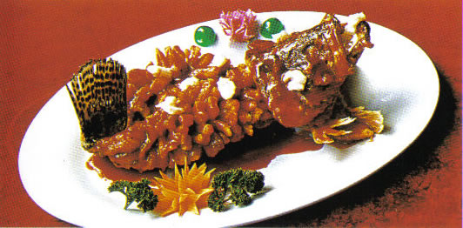

Squirrel Mandarin Fish

But just like other big cities in China’s economically developed areas, you can also find all 8 styles of Chinese cuisine in Suzhou. Other than the western cuisine that is available from hotel restaurants, there are the well-known American brand names like Pizza Hut, Papa Johns, KFC, MacDonalds, TGI Friday, Macaroni & Cheese and even Chili’s. There is even a street completely covered by Japanese restaurants. Imagine the demand for fresh seafood, especially salmon!

Suzhou is also the home of the famous Hairy crab. Hairy crabs originally grew in the Yangtze River Delta area only. The ones from Yangcheng Lake, which is in the Suzhou area, are regarded as the most prestigious and delicious. They are also the priciest ones - top quality Yangcheng crabs can cost up to $100 per pound. People living in the Yangtze River Delta area are crazy about these ugly looking creatures. They will spend considerable sums of money to enjoy the Hairy crab several times a year. More recently, these crabs are being sold all over China, as well as in Hong Kong, the United States and Europe. They move along with the people who love them as they relocate elsewhere.

Trend and Prospects

- Due to the fact that most foreign invested companies are located in the surrounding towns of Suzhou municipality, economic development in those areas has grown tremendously too. There is a rapidly growing demand for retailing services. Supermarkets have noticed the trend and built their second or even their first outlets in areas surrounding Suzhou. There were 13 supermarkets under construction in 2006, of which 11 are located in the surrounding towns.

- Private car ownership is amazingly high in Suzhou, totaling around 560,000. That makes one car for every 11 people in the Suzhou municipality, or one car for every 4 residents in urban Suzhou. This means almost every household in the city has a car! With the high volume of private cars in Suzhou, people tend to purchase their food in a supermarket that offers convenient parking and everything they need in one location. Metro definitely has an advantage in this respect.

- Infrastructure - Even though Suzhou has always been easily accessible, either by car, by train or by water, its rapid development has required a more sophisticated transportation system. Suzhou has dedicated funds to improve its infrastructure for several years now. Several new highways have recently been built, as well as bridges across the Yangtze River, and a much larger and modern railway station is under construction. A light rail system and numerous roads have been scheduled for completion in 2008. Zhangjiagang, Changshu and Taicang are the three harbors along Yangze River. Four more container terminals have been put into use this year, increasing Suzhou’s container loading ability to more than one million a year.

Today’s Suzhou

Constraints

- Suzhou people, much like other Chinese, do not know how to consume certain American food products, like breakfast cereal. Cereal is widely available in the Suzhou market, and the younger generation appreciates the value of trying new products, but they do not know how to eat them. One distributor noted that most people eat cereal as a snack, like popcorn, while they are watching TV.

- Packaging is not suitable for local consumers. Two points need to be mentioned: first, a lot of consumers buy imported goods as a status symbol. They also give them as gifts, so they want the packaging to look as attractive and luxurious as possible. Many American exports do not meet this requirement. In this respect, U.S. products lose market opportunity to European products. Second, for imported goods - especially new products - consumers want to be able to try them first, so if the only available product in the market is a 2-pound package, most of them will say no.

Recommendations

- Promotions. A promotion in a high-end chain hotel with a celebrity chef would be a good approach in a city like Suzhou. Supermarket promotions, particularly holiday-themed promotions to familiarize local consumers with American products and how they can be used are also recommended.

- Distribution. Identify the best distribution channel for products. Also, help develop more diversified food distributors. Local hotels and high-end restaurants are starving for new products and new recipes to create, but the supply is very limited. Someone who is very familiar with U.S. products could help to identify the market need.

- Image. High quality American food products with an emphatic American image and appealing packaging would be very attractive to local customers.

- Advertising. Target advertising through magazines and other media, like TV. These channels have great influence on consumer choices, and are especially effective among young children, who will ask their parents to buy anything they have learned from the media. As most Chinese families have just one child, parents want to give them what they want.

- Education. Educate consumers, teach them how to use American products, teach them why American food is healthier and beneficial to them.

- Convenience. Working consumers have a huge demand for easy-to-prepare foods, frozen or microwaveable meals. This would be a great niche for American exporters.

Suzhou: Best Product Prospects
Product | Market | Notes
Cheese | retail and restaurant | Although this market is very competitive, there is a demand for Edam, Gouda, Swiss, Cheddar and Parmesan cheeses. In Suzhou, these products are found mainly in hotels and buffets.
Beef | restaurant | Imports of U.S. beef are currently suspended; however, traditional beef dishes available on "a la carte" menus are very popular. The majority of Suzhou's beef is from Beijing and Hubei, or imported from Australia.
Breakfast Cereal | retail and restaurant | Growing demand for breakfast cereal in large retail chain stores. High end hotels have cereals available in breakfast buffets.
Lamb | retail and restaurant | Lamb dishes are particularly appealing. The majority of imports come from Australia and New Zealand, as well as China's remote provinces Xinjiang and Inner Mongolia. Lamb dishes are found in high end restaurants as well as local cafes. Local cafes use domestic lamb in order to save money.
Flour | restaurant | Small demand for flour in pastry cooking; some flour is already imported from the U.S.
Chocolate | retail and restaurant | Swiss chocolates are used in pastries sold in hotels and bakeries. The product is usually mixed with chocolate flavoring in Beijing, and is sometimes marketed as "not real chocolate product".
Butter | retail and restaurant | Growing demand primarily for use in pastries. Local F&B managers see a growing demand for butter, although competition exists from sources such as Australia and New Zealand.
Wine | retail and restaurant | Imported wine is extremely popular and there is great potential for growth in restaurants and retail outlets.

Join Us!

Contact ATO/Shanghai to obtain up-to-date information on demographics, infrastructure, policies, distribution channels and market trends in Suzhou as well as other Emerging City Markets in eastern China.

U.S. Agricultural Trade Office, Shanghai
Shanghai Center, Suite 331
1376 Nanjing West Road
Shanghai 200040, China
Phone: (86-21) 6279-8622
Fax: (86-21) 6279-8336
E-mail: ATOshanghai@fas.usda.gov
Website: www.USDAChina.org

