USDA Foreign Agricultural Service
GAIN Report

Template Version 2.09

Global Agriculture Information Network

Voluntary Report - public distribution
Date: 8/20/2004
GAIN Report Number: CI4023
CI4023
Chile
Product Brief
Cheese and Dairy Products Brief
2004

Approved by:
Christine M. Sloop, Agricultural Attaché
U.S.Embassy Santiago
Prepared by:
Office of Agricultural Affairs

Report Highlights:
Chile’s processed dairy product market is strongly influenced by European technology. Few imported dairy products are competitive and the main barriers are market acceptance, shelf life and price. Cheese faces the fewest obstacles among potential dairy product exports to Chile.

Includes PSD Changes: No
Includes Trade Matrix: No
Unscheduled Report
Santiago [CI1]
[CI]
Table of Contents
Section I. Market Overview 3
Section II. Market Sector Opportunities and Threats 4
Entry Strategy 4
Market Size, Structure, Trends 6
Market Size 6
Imports 7
Local Production 8
Exports 9
Market Structure – Distribution Channels 9
Market Trends, Consumer Demand and Preferences 11
Opportunities 12
Competitive Threats and Obstacles 14
Company Profiles 15
Relevant Private and Public Institutions 17
Section III. Costs and Prices 18
Tariff Rates, Quotas, Import Duties 18
Inspection Fees and Customs Broker’s Fees 19
Cargo Unloading, Transport and Storage Fees 19
Value-added Tax 19
Average Markups 19
Prices 20
Section IV. Market Access 21
Chilean Food Regulations 21
Chile Import Requirements for U.S. Dairy Products 28
Export Certificate Animal Products 32
Instructions for Completition of Sanitary Certificate Worksheet for Export 33
Sanitary Certificate for Exports 34
Section V. Key Contacts and Further Information 35
Annex 1. Chilean Imports of Cheese, Powdered Milk, Butter and Milk Whey, Year 2003 37
Annex 2. Imports of Cheese, Powdered Milk, Butter and Whey, 1999-2003, Thousands of US$ CIF 40

Section I. Market Overview

The processed dairy product market in Chile is strongly influenced by European technology, investors and product types. There is a wider variety of dairy products in Chile than in the U.S., approaching that in Europe, especially among yogurts, dairy desserts and the very popular “Bio” or “Health and Wellness” products targeted at higher-income, health-conscious ABC1-level consumers. Fine cheeses are 2-3 percent of the total cheese market, which favors soft fermented farm-type cheeses.

Few imported dairy products aside from powdered milk, cheese and some other products such as whey are competitive in Chile. The main barriers are market acceptance, price, product shelf life and minimum order quantities in relation to local retailer quantity and shelf life requirements. For these reasons, cheese faces the fewest obstacles among potential dairy product exports to Chile, as it can last as long as one year. However, establishing a European-like market image of high quality and sophistication for U.S. processed dairy products, especially cheese, requires a very strong promotional effort and competitive pricing. This is necessary to overcome the image of and preference for European cheeses on the one hand and the more competitive price of Brazilian and Argentina processed dairy products on the other. This is exemplified by Kraft, which successfully introduced Philadelphia cream cheese into Chile several years ago through strong advertising, although it has not succeeded with other dairy product categories.

The main dairy items produced in 2003 were powdered milk (62,000 metric tons), cheese (53,000 tons) and fluid milk (311 million liters). The production of these three products required the equivalent to 1,396 million of liters of milk, that is, 89% of the milk received by plants.

Cheese consumption drops in summer as milk production goes up. This has triggered a strong push to process and export surplus milk as cheese and the development of several new varieties of locally made cheeses that substitute for imported cheeses such as Gruyere, Camembert, Roquefort and Parmesan.

Total Cheese imports grew 25.4% in 2003, reaching 4,128 tons and 9.64 million dollars. Argentina accounts for 52% of total cheese imports by volume, followed by Brazil (16%) and the U.S. (11%). Gouda cheese is the main type 47% of total imports by volume and 41% by value. Argentina supplies 78% of imported Gouda cheese by volume and 79% by value. The overall trend is one of growth but with significant year-to-year variation, which is linked to the variations in local production.

Other important dairy product imports in 2003 were Low-Fat Powdered Milk (15 million dollars), High-Fat Powdered Milk (28.3 million dollars), Butter (4.5 million dollars) and Milk Whey (5.6 million dollars).

Advantages and Challenges for US Exporters of Cheese and other dairy products

Advantages | Challenges
U.S. dairy processors are capable of strong product differentiation. Premium products in Chile are differentiated by brand or origin. | The processed dairy products market in Chile is patterned after the European one and offers a much wider variety of products than that seen in U.S. supermarkets.
Overall, U.S. dairy product quality is recognized to be on a par with large local producers (Nestle, etc.) and better than the small ones. | Fluid product (milk, yogurt, and desserts) quality is good, but cheese quality (flavor, etc.) needs improvement. US cheeses do not have as strong a brand or market recognition as European products.
Chilean consumers trust U.S. labeling more than local one. U.S. dairy products have image of high quality and adherence to best manufacturing practices and principles. Sugar free really is sugar free when it is a U.S. product. | Consumers have negative perception of U.S. products with long additive lists as more “artificial” or less “natural”.
Because of their experience and good technology, US dairy or cheese products that could find potential in Chile are those with value added or substitute. | Cheese and in general food products from United States are considered to be more artificial in ingredients, thus in taste, than local products. Strong cheeses are only slowly finding approval in Chile.
In general US food products are presented in very attractive and original packaging, which can allow them to compensate for their lack of market recognition. | Key market entry obstacles are Price with retailers and consumers and Shelf Life with retailers. Shelf life for U.S. products is less than for European products, in part due to allegedly more advanced European technology.
New free trade agreement between Chile and United States will reduce costs of U.S. products, making them more competitive in the market. | It is difficult for U.S. cheese and other dairy products to compete with costs of products manufactured locally and from Argentina or other South American countries because the labor, consumables and shipping are cheaper.
U.S. companies have the experience and resources for a strong market penetration strategy. Choose a distributor carefully and ensure that the distributor complies with your quality, customer service and delivery standards. | Finding a good, reliable exclusive distributor is not easy. Manufacturers normally fail when they try to enter the market without a brand development strategy and without investing in advertising or supporting their distributor against the established market leaders.
 | Lack of nearby plant makes U.S. products less competitive due to shipping problems (time, expense, cold chain, etc.), diminished shelf life and inability to reprocess products returned by retailers.

Section II. Market Sector Opportunities and Threats

Entry Strategy

- The Chilean market is not large, but it is very competitive and price-conscious. Chilean dairy product consumers have rapidly accepted innovations in convenience and health foods such as desserts and yogurts, but they are not adventurous when it comes to cheeses and are only slowly acquiring a taste for stronger-flavored cheeses than the traditional soft farm-type cheeses. There is a widespread lack of knowledge and sophistication related to non-traditional cheeses, especially spreadable cheeses, and the variety of imported cheeses only leads consumers to confusion. Therefore any market penetration effort should include resources for a strong marketing campaign including advertising (especially on television), a strong product launch, and point-of-sale marketing.

- The main component of a point of sale promotion program for cheese and food products is to have promoters in key supermarkets offering product samples for shoppers to taste, as well as marketing literature to educate them about new processed dairy food products, their nature and unique characteristics and how to use them. A special section in the Cheese section for fine cheeses can help the introduction. D & S, Chile’s largest supermarket chain (Lider stores) has a “Flavors of the World” (Sabores del Mundo”) section in their higher-income level location stores, which at this time does not have any U.S. cheeses on display because the U.S. cheeses do not have a world-class image in Chile. Kraft Philadelphia Cream Cheese is an exception. It was introduced with significant initial investments, caught on as people learned how to use it, and now grows without much aid based on brand recognition and formed consumer habits.

- To start having success in Chile, U.S. cheeses need a strong strategic brand image building campaign. Tasting and consumer education are an important part of this. Along with this, U.S. dairy products need to be available in a wider variety of flavors and presentations comparable to the European market, in packaging that is in proportion to local sizes, with fewer calories per serving, and to have a longer shelf life than they do now, more in tune with European products, to compete with Chilean products.

- Emphasize non-refrigerated products with long shelf life initially, especially cheeses, but price will be an issue. Even long-life yogurts (e.g. no-cold-storage, 6-month shelf life Iparlat yogurt from Spain) have not really entered yet.

- Sales in Chile are made based on a relationship of personal trust, and personally visiting the country and demonstrating products to potential distributors and end-users is fundamental for generating solid, durable business relationships. It is essential to find a good importer/distributor, with experience, good reputation and good contacts and knowledge of food import regulations and procedures. The distributor should be accustomed to dealing with demanding supermarket chains and their specific requirements.

- Cheese and dairy products are sold mostly by price; therefore US suppliers should find the way to be competitive. Profit margins in Chile are very commonly significantly slimmer than in the U.S. for the same product. Because some local cheese producers also import cheese, this avenue of forming joint ventures should be explored. Products could be developed locally to avoid the obstacles faced by imports (shelf life, cold chain, price, non-recyclability, etc.). Kraft is successful in Chile because it has a local office, but even so it has not generally been successful with dairy products because of a lack of a local plant.

- Take advantage of gourmet or food trade shows to exhibit products and contact potential importers and end users. Two annual shows to consider in Chile are “ExpoGourmand” and “ExpoAlimenta” (www.expotrade.cl). Chilean food retailers also visit shows such as Expo Abras in Rio de Janeiro, Brazil and Fispal in Sao Paulo, Brazil. Publishing ads and articles in wine-related and gourmet magazines, including weekend newspaper magazines, is also an option.

- As a recommendation, it is essential to be aware of the fairly limited size of the Chilean market and to seriously commit to pursuing it, to provide strong support to the distributor and clients, and to be patient.

Market Size, Structure, Trends

Market Size

Cheese consumption in Chile is 10 lbs. per capita, higher than the world average of 5.5 but low compared to Argentina’s 18, the US’s 30 and Europe’s 36 (average) lbs. per capita. Although statistics indicate that the estimated cheese consumption in 2003 dropped to 9.5 lbs. per capita, compared to 10 lbs. per capita in 2002, the general trend is up. The drop in 2003 was the result of an increase in exports to 5,541 tons, which was 126.5% higher than in 2002. It also reflects the increase in cheese retail prices. ODEPA, the government agricultural planning service, states that 53 thousand tons of cheese were produced by the large producers in 2003 and a year-on-year growth rate of 12.6% for the January-June 2004 period. The Chilean Dairy Association estimates that Chile produced a total of 60-70 thousand metric tons of cheese in 2003 and exported 8-10 thousand tons.

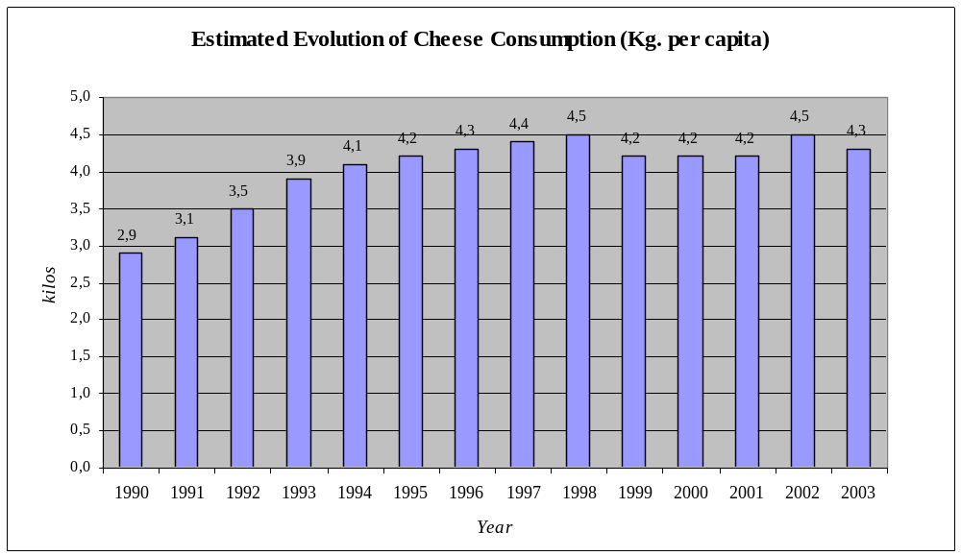Even though cheese exports are growing in 2004, it is estimated that the cheese consumption will also increase thanks to the increase in local production (by large cheese industries and also small producers), to the increase in imports and to the continuing growth of personal income among the population.

A wide variety of cheeses are sold in the market, among which Gouda is the main one, followed by Chanco (country type similar to Gouda in texture but milder). Locally produced Gouda and Chanco and imports (only Gouda) account for around 80% to 90% of the total market. Chanco cheese is the traditional type consumed in Chile and it is produced by the large dairy industries as well as by an estimated 100 small cheese producers located mostly in southern Chile. These small cheese makers sell their products mostly for local consumption and prices depend on quality and prestige.

Other cheese types produced in smaller proportions are Parmesan, Mozzarella (sold mostly to fast food restaurants selling pizza), Cheddar, Edam, processed cheese, cream cheese (mostly Kraft Philadelphia Cream Cheese), and others. Laminated (sliced) cheese to be used hot and melted, with fast growing sales, has become an important cheese consumption driver. Besides cheese made of cow milk, cheeses made with goat and sheep milk are becoming more popular in the market, which shows a long overdue, gradual increase in consumer sophistication. Imported cheese has further increased the diversity and supermarkets now offer cheese from Argentina, Uruguay, Brazil, Germany, New Zealand, France, Italy, Spain, Holland, Switzerland, etc. The most popular are Gruyere, Camembert, Roquefort, Sheep type and Cheddar.

Competition is strong. For instance, the Lider supermarket chain, which is part of D&S and one of the main participants in the retail market, works with around 25 different cheese suppliers (local producers and importers) and has around 100 different cheese products. On locally made country cheese it is easy to find at least 15 different types in any large supermarket.

Imports

Table 1. Chilean Imports of Cheese and Main Imported Dairy Products

Year |  | Cheese  (Heading 0406) | Powdered Milk, fat content not exceeding 1.5%  (HS 0402.1000) | Powder Milk, fat content exceeding 26% (HS 0402.2118) | Butter  (HS 0405.1000) | Milk Whey (Heading 0404)
2004  Jan-June | Tons | 2,708 | 1,176 | 3,585 | 2,059 | 2,850
2004  Jan-June | US$ CIF | 6,731,924 | 2,126,239 | 6,973,093 | 3,510,725 | 2,918,277
2003  Jan-Dec | Tons | 4,128 | 8,692 | 15,539 | 2,925 | 5,307
2003  Jan-Dec | US$ CIF | 9,642,533 | 14,999,849 | 28,284,055 | 4,528,502 | 5,599,763
2002  Jan-Dec | Tons | 3,293 | 5,486 | 2,358 | 465 | 1,862
2002  Jan-Dec | US$ CIF | 7,145,610 | 7,807,351 | 3,093,179 | 622,69 | 1,826,544
2001  Jan-Dec | Tons | 3,045 | 5,851 | 4,428 | 835 | 2,298
2001  Jan-Dec | US$ CIF | 7,750,559 | 12,428,902 | 9,064,173 | 1,463,527 | 3,324,841
2000  Jan-Dec | Tons | 6,631 | 9,135 | 6,936 | 1,830 | 2,443
2000  Jan-Dec | US$ CIF | 14,900,083 | 16,705,329 | 13,401,331 | 2,887,416 | 2,765,105
1999  Jan-Dec | Tons | 3,602 | 9,428 | 2,743 | 446 | 1,300
1999  Jan-Dec | US$ CIF | 8,783,442 | 13,427,371 | 4,387,018 | 1,075,635 | 1,308,241

Cheese imports grew 25.4% in 2003, reaching 4,128 tons. Argentina was the main supplier with 2,165 tons, or 52% of the total imported. Brazil followed with 661 tons and then the United States with 437 tons, which is 11% of total. Other origins were Germany, Uruguay and New Zealand. Cheese imports from New Zealand accounted for around 70% of imports (4,655 tons), in the year 2000, mostly Gouda cheese, but this surprisingly dropped to 72 tons in 2002. This is probably due to increased imports from Mercosur countries which entered the country with very low import tariffs as well as record low prices as their economies and currency exchange rates suffered, which makes for very strong competition for U.S. products. Another reason is that Soprole, which is the main importer of products from New Zealand, is producing more locally. In any case in 2003 there is a small recovery of imports from New Zealand reaching the 195 tons. Products from New Zealand are relatively low in price; thus they can compete well with products from Mercosur.

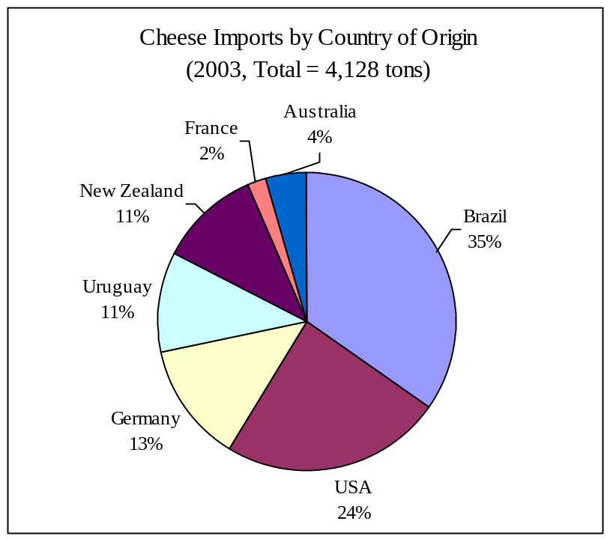

The main type of cheese imported from the U.S. was cream cheese, reaching almost 361 metric tons. In fact, most U.S. cream cheese was imported by the Chilean subsidiary of Kraft Foods. Kraft has been in Chile since 1994 and sells snack products such as chocolates, cookies, powdered desserts, etc. In dairy products they only sell cream cheese in Chile, which is sold only to Soprole (one of the largest dairy product producers in Chile). Philadelphia Cream Cheese is sold only in supermarkets visited by upper income level shoppers and represents a small part of Kraft’s business in Chile. Their imports come from US as well as other locations where they own plants such as Colombia, Brazil, Europe, etc.

Cheeses imported from United States were Gouda, Roquefort, Parmesan, Powdered Cheese and Processed Cheese.

Local Production

Cheese production in 2003 was 53,000 metric tons, which is very similar to the quantity registered in 2002. To this production we have to add the smaller cheese producers, which are estimated to account for more than 13,500 tons.

In the first quarter of 2004, large dairy industries boosted cheese production by 13%, credited mostly to Soprole, which has a yearly contract to sell 7,000 tons to Mexico. Cheese production by other large dairy processors and also by smaller cheese producers is expected to increase in 2004. Even though the exact production by smaller cheese producers is not available, it is known that these companies are advancing in production volumes and also technologically, which is making them very competitive in the market.

The main dairy items produced in 2003 were powdered milk (62,000 metric tons), cheese (53,000 tons) and fluid milk (311 million liters). The production of these three products required the equivalent to 1,396 million of liters of milk, that is 89% of the milk received by plants (see table below).

Table 2. Milk Reception at Plants and Dairy Product Production.

 |  | JANUARY-DECEMBER
PRODUCT | UNITS | 1999 | 2000 | 2001 | 2002 | 2003
MILK RECEPTION | LTS | 1,469,716,292 | 1,447,213,009 | 1,636,461,297 | 1,605,391,798 | 1,563,169,284
Fluid Milk Production | LTS | 279,481,516 | 275,193,430 | 291,268,257 | 295,909,345 | 310,751,512
Powdered Milk Prod. | KGS | 60,596,660 | 59,088,156 | 71,463,856 | 67,709,599 | 61,867,045
Curd Cheese | KGS | 7,034,377 | 7,166,620 | 7,150,433 | 7,479,974 | 7,555,476
Cheese | KGS | 44,777,139 | 44,717,992 | 50,416,509 | 53,074,751 | 53,037,176
Yogurt | LTS | 100,203,007 | 106,623,501 | 95,249,538 | 127,057,261 | 139,343,652
Cream | KGS | 13,142,437 | 16,125,411 | 17,544,062 | 17,631,470 | 16,760,286
Butter | KGS | 11,006,560 | 9,855,236 | 11,836,134 | 11,551,232 | 10,848,961
Powdered Milk Whey | KGS | 11,862,924 | 14,105,471 | 15,783,682 | 14,285,559 | 15,239,684
Condensed Milk | KGS | 15,742,230 | 24,400,340 | 25,418,149 | 24,190,214 | 30,558,318
Caramel | KGS | 20,783,943 | 21,963,910 | 24,139,771 | 26,105,067 | 26,637,591
Modified Milk | KGS | 1,250,350 | 3,518,100 | 3,293,470 | 1,484,270 | 1,938,278
Evaporated Milk | KGS | 15,930 | 313,640 | 1,003,430 | 93,180 | 0

Exports

The main dairy product exported in year 2003 was cheese, which increased 126,5% with 5,541 tons in 2003 and whose main destination was Mexico representing 90% of exports and where Gouda cheese was the most exported type. Other destinations were Cuba (5%) and the United States (2%). Exports to the U.S. were mostly Roquefort and Parmesan cheeses. Condensed milk exports increased 54% in 2003.

First quarter 2004 cheese exports were 192.3% higher than the same period in 2003, due mostly Soprole’s increased exports to Mexico.

Market Structure – Distribution Channels

Cheese is sold in supermarkets, public wholesale markets and the traditional market (including street markets and grocery stores). Some studies say supermarkets account for 20% of total cheese sales, other say they represent 40%. In any case, it is known that much cheese is still being sold in neighborhood grocery stores and public markets, but the specialty cheeses are to be found in supermarkets and specialty stores, even department store delicatessen.

The distribution channels for cheese in Chile vary depending on the company. Large cheese producers sell directly to supermarkets, open public markets as well as to the traditional markets. In the case of Soprole, one of the largest producers, 50% of their cheese goes to supermarkets and the other half goes to the open public markets and the traditional segment. Many small cheese producers sell predominantly to grocery stores and they do it directly. Procesadora de Alimentos S.A. (Prodeasa), a strong importer that accounts for 18% of imported cheese, sells to one wholesale company, which sells to the public markets and to the traditional market. Prodeasa also sells cheese to the supermarkets (directly) but this is a small portion of their overall sales. The main cheese importer, Santa Rosa Chile Alimentos Ltda. (Los Fundos), sells only to supermarkets and they do so directly, without intermediaries. Supermarkets also import cheeses and many other food products but they do it sporadically because they would rather buy from an importer and free themselves of all the import procedures and other aspects involved, such as managing stock and pulling products off the shelf as the expiration date approaches.

Supermarkets admit that selling to them is complicated. In selling to supermarkets, the distributor is crucial because he needs to understand each chain’s purchasing system and replenishing requirements. The distributor is expected to keep sufficient stocks of products with sufficient shelf life in his own warehouse, to replenish the shelves and to take back those products that have less than a certain shelf life left.

Table 3. Supermarket market shares, May 2004

Supermarket Chain | % Market Share
D&S (Lider) | 32.0
Cencosud (Jumbo) | 21.0
San Francisco | 3.2
Unimarc | 3.1
Rendic | 3.1
Montserrat | 2.7
Montecarlo | 2.7
Others | 32.2

Distribution channel diagram for cheese in Chile.

U.S. EXPORTERS

IMPORTERS
SMALL CHEESE PRODUCERS
LARGE CHEESE
PROCESSORS

WHOLESALE DISTRIBUTORS

OPEN PUBLIC MARKETS
TRADITIONAL MARKETS

SUPERMARKETS

Market Trends, Consumer Demand and Preferences

The Chilean market is split into two social segments as far as buying premium food products goes. The ABC1 segment knows and appreciates good dairy products (health products, fancy cheeses, etc.) and pays for them even if they have to pay “import” prices. This is 15-20% of the total market. This segment is also leading a strong growth of the “to go” packaged products mainly for school children’s snacks. The other, less affluent segment goes strictly for price and is not interested in experimenting with new product varieties.

Retailers have observed that “diet” products are perceived negatively by Chilean consumers as being intended for people with health problems as a medical option. The trend is to call low-calorie products “light” products, as in Europe, which conveys the positive image of products for persons who are actively engaged in furthering their wellness. This product category has been growing strongly, but diet cheeses are perceived to have “too much chemistry”.

In terms of cheeses, Chileans prefer soft, mild types, not strong ones. For decades Chileans placed mostly Gouda and Chanco cheese on the table on a day-to-day basis and other specialty cheeses in reduced quantities for special occasions. Now the market is increasingly acquiring a taste for and demanding new cheese types and origins such as Parmesan, Camembert, Gruyere, Edam and even the strong Roquefort. European cheese varieties that have done well in Chile are Emmental (Swiss) and blue cheeses, and Philadelphia cream cheese from the U.S. Camembert and Brie cheeses are expensive and do not sell well, and Cheddar is one of many whose application is not well understood. Cheddar is widely used for hamburgers in Chile.

These products are imported but there are already local companies forming alliances with European producers in order to manufacture special types of cheese in Chile. Sales of these delicatessen – as these products are still being considered in Chile - are still limited but are growing and providing better profit margins than the traditional cheeses. Supermarkets are following this trend and thus they are trying to educate consumers and get them to eat a wider variety of cheeses and distinguish the different flavors. They are very careful on how to display cheese on the shelves and they invest a lot in promoting them, but the supermarket layout is still not conducive to differentiating among cheese classes, for example among spreadable ones.

A characteristic of specialty cheese sales is that they are bought by the mother, or by the father on weekends, who quickly leave the cold refrigerated area without spending much time comparing the products.

Traditionally cheese had been sold by cutting portions from the whole cheese at the counter following the customer’s indications, and customers still prefer this system, even for sliced cheese. But pre-packaged cheese is becoming an important item in refrigerated showcases, especially in supermarkets. Traditional markets (corner groceries stores) get best results by offering smaller bars of cheese of around 4 lbs. Most of the time distributors sell 8 to 9 lb. bars to the smaller stores.

Goat cheese is a product that has been well received in the market and small companies manufacture it with simple technology. One interviewee believes that there is a need for suppliers with experience in this product and that can offer better prices, so that it can be accessible for more people.

Opportunities

There are good market opportunities in Chile for U.S. dairy processors that can expand the variety and technology of their product lines. The highest market potential is among non-refrigerated products, since refrigerated imports are too perishable and expensive to ship by air.

Supermarket contacts stress that the Chilean dairy product market is very close to the European one in variety, style and technology for processed products, whereas the U.S. supermarkets has very little product type and brand variety, especially among yogurts and desserts. The European technology helps in delivering high quality products with good flavor and long shelf lives. The “Bio” or Health and Wellness type products that are so popular in Europe are undergoing strong growth in Chile. These are reportedly just recently becoming an important category in the U.S. Items like Kraft’s Diabetic Choices products are growing strongly in Chile as diabetes is growing three times faster among youngsters than among adults.

One as yet non-existent product type with high potential demand in Chile is the type of dairy product that substitutes for Mozzarella cheese and is used by pizza chains and other such franchise chain operations, sold in coarsely ground fashion.

Flavored butters have been indicated as another example of value-added products with market potential, representative of U.S. manufacturers’ diversification capability. Land O’Lakes entered Chile with such products at one time but could not compete on price. The situation may have changed now.

If we analyze import statistics (see table Nº 3) we see other imported dairy products that have increased their penetration in Chile. Such is the case of whole and skimmed powdered milk, imported mainly from Argentina and Uruguay and mainly because the local production was not enough to supply the market in 2003 (in 2003, the United States had no share of imports of this product). Powdered milk is 35% of the Chilean milk market, and this is basically because of the dominating Nestle name. Establishing a good brand would be a way of gaining market share, but the marketing investments and Nestle’s reaction must be taken into account.

Butter imports increased by 530% in 2003 mainly because there was a deficit of milk fat since it was used in the production of other dairy products leaving a smaller quantity to make butter out of (US import participation was only of 0.07% in this item). The main country of origin for butter was Uruguay followed by Australia.

Powdered milk whey imports increased by 130%, reaching 5,307 tons in 2003. Imports of powdered milk whey came mainly from Argentina and France. The United States is in third place in imports with 1,307 tons (25% of total imports). This could present a good opportunity for US exporters depending on their product quality, even though the market is small and there are still many producers that throw away this product because they do not have the capacity to dry the powdered milk whey (which is the reason why it is imported). Powdered milk whey is used to produce ice cream, cakes, etc.

Another area of opportunity is specialty powdered milks developed as baby formulas or enhanced prenatal and postnatal milk for mothers. Milk for mothers-to-be is all imported from Argentina (Sancor brand). Nestle is strong among baby formulas, which are presented for ages 0-6 months, 6-12 months, and 1-4 years.

Table 4. Key Dairy Products with Potential for US Producers, Principal Competing Countries, Jan-Dec 2003.

HS Code | Product | Total, US$ CIF x1000 | US,  US$ CIF x1000 | US, Mkt. Share | Main Competing Countries
0402.1000 | Powdered milk with 1.5% or less fat | 15,000 | 0.0 | 0.0% | Uruguay-43%, Argentina 28%, Canada 19%, Germany 3%
0402.2118 | Powdered milk with 26% or more fat | 28,284 | 0.0 | 0.0% | Argentina-59%, Uruguay 22%, Ireland 8%, New Zealand 12%
0404.1000 | Whey | 3,933 | 706.3 | 18.0% | Argentina 31%, France 23%,  USA 18 %, New Zealand 12%
0406.1030 | Mozzarella cheese | 1,727 | 0.0 | 1.4% | Argentina-58%, Brazil 34%, Uruguay 8%, Australia 0%
0406.9010 | Gouda cheese | 3,958 | 0.4 | 0.0% | Argentina-84%, Germany 11%, New Zealand 9%, Uruguay 1%
0406.9090 | Cheese, other | 940 | 61.8 | 6.6% | France-18%, Holland-15%, Argentina-14%, Germany-14%

Table 5. Comparative Table, Key Dairy Products with Potential for US Producers, 2003 vs. 2002.

HS Code | 2002  Total  US$CIF x1000 | 2003  Total  US$ CIF x1000 | 2002  US  US$ CIF x1000 | 2003  US  US$ CIF x1000 | 2002  US  Market Share | 2003  US  Market Share
0402.1000 | 7,807 | 15,000 | 0.0 | 0.0 | 0.0% | 0.0%
0402.2118 | 3,093 | 28,284 | 0.0 | 0.0 | 0.0% | 0.0%
0404.1000 | 1,704 | 3,933 | 385.5 | 706.3 | 22.6% | 18.0%
0406.1030 | 1,118 | 1,727 | 16.2 | 0.0 | 1.4% | 1.4%
0406.9010 | 2,755 | 3,958 | 35.7 | 0.4 | 1.3% | 0.0%
0406.9090 | 1,323 | 940 | 576.1 | 61.8 | 43.5% | 6.6%

Competitive Threats and Obstacles

What might be considered threats for U.S. dairy products is the market image, distribution strength and the wider product variety European companies. A majority of these products are already in the Chilean market and are distributed nation-wide by companies such as Nestle and Soprole (controlled by Fonterra of New Zealand), the two largest firms in the market.

Another threat is the fast market acceptance of “Bio” type products in Chile, replicating the strong demand in Europe, a market sector in which the U.S. dairy industry has not geared up for to the same extent. The Chilean food market is a mature one in which more attention and money are being spent on healthy food.

A third threat is that there are several small local dairy processors that can quickly copy the nature and the packaging of the product. One way around this is to patent brands and product names and package styles.

The two biggest obstacles to importing processed dairy products from the U.S. are shelf life, which is normally shorter than from other origins, and food regulations that are in some cases more stringent than in the U.S. or in Europe. A one-shot obstacle is the need to get the products approved by the health authorities. This can take a significant amount of time and at times be impossible because the product does not comply with local regulations, but once approved it is then much simpler for later regular shipments. Vitamin and mineral contents, for example, are tightly regulated with regard to maximum contents in food products in Chile (see Section IV, Market Access).

Shelf life requirements vary among supermarket chains. Yogurts and desserts generally have a 30-day shelf life, are delivered to the supermarket at most 5 days after manufacture and are pulled off the shelf again 5 days before the “best before” expiration date, leaving 20 days in between for display on the shelf. In another case they must be delivered within 7 days of manufacture and pulled off again when about half of the shelf life is gone (i.e., 15 days before expiration).

Chilean cheeses have about 90 days of shelf life. About 10-15% of that has already passed when they are placed on the shelves and they are pulled off one chain’s shelves when only 1/2 of their life remains. In another case, assuming a cheese lasts 6-8 months, it is assumed that one-third of the shelf life goes by during distribution, another third on the supermarket shelf, and the last third in the client’s possession. European cheeses have better shelf lives than Chilean or U.S. products due to more advanced technology, we were told, and are found in supermarkets where few if any U.S. products are present. Imported cheeses can last up to one year, arrive two months after date of manufacture and are sold within 3-4 months, so that the ½ of shelf life condition is again normally met.

Another set of obstacles is related to getting supermarket shelf space. The product must be attractive enough to displace another one on already-full dairy product shelves. This requires an investment in strong point-of-sale marketing and distribution (stock management, shelf replenishing, etc.). These costs work against the narrow profit margins of commodity products, so that value-added products with market appeal have a better chance of doing well.

It is very often easier to import food products from Europe than the U.S. because U.S. exporters have not developed a culture of working with small export markets as European ones have. European exporters are more flexible in adapting packaging to local tastes and requirements (such as smaller portions), incorporating new labels, and manage shorter delivery times. U.S. food product exporters are much less willing to send less than full-pallet loads (like ½ pallet) or in smaller wholesale SKU containers (e.g. 12 instead of 24 retail boxes), etc. This creates excess stock problems for slow turnover items and the need to repackage wholesale containers to match the locally accepted quantity before delivery to retailers.

Further obstacles for an importer are low initial sales and slow product turnover rates and not having a nearby processing plant for its dairy products. This is because Chilean law allows processors to recycle products when they need to remove them from supermarket shelves and before expiration. Importers with no local plant cannot do this, which adds significantly to the cost of doing business, and they cannot even give the products to charity after expiration.

Finally, it is even harder to overcome the still insufficient cheese culture than changing consumer habits regarding specialty value-added dairy products and health-oriented products when manufacturers and retailers have made few efforts to educate the consumers. This is especially true when D&S, Chile’s largest supermarket chain, is imposing Every-Day Low Prices (EDLP) policies on the market.

Company Profiles

The dairy food processing sector, the nucleus of the dairy industry production chain, is made up of around 15 companies that run 28 plants which process 75% of the local milk production and where the leading five companies buy 90% of the milk (year 2000). These five companies are Nestlé, Soprole (New Zealand Dairy Board) and Parmalat, of foreign capital, plus the local Loncoleche and Colun operations. The other companies are mid-sized or small and most of them produce cheese. The milk producers are the main suppliers, and supermarkets are the main retailers. Dairy products, at 7.5%, are the second largest supermarket perishable sales group after meats.

Table 8. The ice cream market is over $100 million and is dominated by Savory (Nestlé) and Bresler (Unilever).

Company  (Product Types) | Sales (US$) | End-Use Channels | Production Location(s) | Procurement Channels
Nestle (dairy, confectionery, cereals and dehydrated soups) | 261 tons in 2002, 13.3% overall packaged food market value share in 2001 | Retail | Chile (8) | Direct (Local and Foreign), Distributors (Local and Foreign)
Parmalat (dairy products) | N/A | Retail and Exports | Chile (2) | Direct (Local and Foreign), Distributors (Local and Foreign), Importers
Proc. De Leche del Sur (Prolesur, in Soprole holding - dairy products) | N/A |  | Chile (3) | Direct (Local)
Soprole (milk, diary products) | N/A | Retail | Chile (5) | N/A

Company Name | Number of Plants | Milk  Reception  (liters) | Fluid Milk Production  (liters) | Powdered Milk  (kilos) | Fresh Cheese  (kilos) | Cheese  (kilos) | Yogurt  (liters) | Cream  (kilos) | Butter  (kilos) | Powdered Whey  (kilos) | Condensed Milk  (kilos)
Soprole | 5 | 353,464,790 | 138,848,684 | 6,970,976 | 5,448,888 | 12,130,727 | 68,142,958 | 5,005,475 | 1,690,174 | 0 | 0
Nestle Chile S.A. | 4 | 301,384,867 | 0 | 26,187,167 | 0 | 0 | 34,296,865 | 2,146,113 | 1,760,795 | 0 | 28,624,904
Quillayes - Peteroa | 2 | 34,551,492 | 0 | 0 | 1,274,650 | 1,823,720 | 0 | 0 | 114,996 | 0 | 0
Vitalac S.A. | 1 | 11,813,740 | 1,835,943 | 0 | 374,746 | 883,726 | 69,964 | 104,004 | 6,158 | 0 | 0
Parmalat Chile S.A. | 2 | 101,663,924 | 7,469,356 | 7,419,845 | 0 | 1,339,765 | 14,821,768 | 859,455 | 542,690 | 861,375 | 1,933,414
Calan Ltda. | 1 | 19,104,726 | 2,356,529 | 182,945 | 67,457 | 874,944 | 5,207,510 | 127,183 | 87,623 | 403,830 | 0
Loncoleche | 3 | 210,310,777 | 48,013,375 | 8,121,450 | 0 | 3,068,181 | 7,661,675 | 5,318,588 | 1,634,637 | 2,420,888 | 0
Surlat S.A. | 1 | 70,086,249 | 37,984,310 | 4,250,732 | 0 | 0 | 165,151 | 801,065 | 783,461 | 0 | 0
Lb Ind.Alimentos S.A. | 1 | 0 | 0 | 0 | 0 | 0 | 0 | 0 | 0 | 0 | 0
Colun | 1 | 280,886,745 | 50,719,225 | 5,657,575 | 281,347 | 17,913,487 | 5,292,556 | 2,197,952 | 2,812,228 | 7,796,175 | 0
Cafra | 1 | 32,643,287 | 5,575,460 | 1,120,421 | 0 | 1,918,051 | 25,216 | 47,078 | 334,885 | 309,706 | 0
Chilolac | 1 | 32,763,145 | 30,515 | 0 | 0 | 3,424,366 | 507,376 | 2,047 | 285,077 | 0 | 0
Lacval S.A. | 1 | 17,607,107 | 17,904,380 | 1,290,984 | 108,388 | 571,916 | 3,152,613 | 151,326 | 90,106 | 0 | 0
Agrolacteos Cuinco Ltda. | 1 | 21,610,646 | 13,735 | 0 | 0 | 2,004,176 | 0 | 0 | 85,186 | 0 | 0
Campo Lindo | 1 | 1,042,634 | 0 | 0 | 0 | 105,021 | 0 | 0 | 0 | 0 | 0
Cumelen . Mulpulmo | 1 | 74,235,155 | 0 | 664,950 | 0 | 6,979,096 | 0 | 0 | 620,945 | 3,447,710 | 0
Total | 1 | 1,563,169,284 | 310,751,512 | 61,867,045 | 7,555,476 | 53,037,176 | 139,343,652 | 16,760,286 | 10,848,961 | 15,239,684 | 30,558,318
Note: Nestlé has four plants only for dairy products. In total, Nestlé has eight plants (including all their products).

Relevant Private and Public Institutions

Fedeleche
Address: Tenderini 187 P. 1, Of. 1, Santiago Centro, Santiago, Chile
Tel: (56 2) 632-9473
Fax: (56 2) 633-0684
E-mail: carancibia@fedeleche.cl
Web Site: www.fedeleche.cl
Contact(s): Mr. Carlos Arancibia, Manager

Ministerio de Agricultura
Address: Teatinos 40, piso 9, Santiago Centro, Santiago, Chile
Tel: (56 2) 593-5000
Fax: (56 2) 393-5135
E-mail: mecastro@minagri.gob.cl
Web Site: www.minagri.gob.cl
Contact(s): Mr. Jaime Campos Quiroga, Agricultural Minister
Mr. Arturo Barrera, Undersecretary

ODEPA - Centro de Información Silvoagropecuaria
Address: Valentín Letelier 1339 - Piso 1, Santiago Centro, Santiago, Chile
Tel: (56 2) 397-3000
Fax: (56 2) 697-7805
Web Site: www.odepa.gob.cl
Contact(s): Mrs. Aída Guerrero
Mrs. Dora Carreño
Mr. Victor Esnaola

Servicio Nacional de Aduanas
Chilean Customs Service, Technical Department
Address: Plaza Sotomayor 60, Valparaiso, Valparaíso, Chile
Tel: (56 32) 200541
Web Site: www.aduana.cl
Contact(s): Mr. Fredy González, Subdireccion Técnica

SESMA-Servicio de Salud Metropolitano del Ambiente
Address: Olivares 1229, Piso 3, Santiago Centro, Santiago, Chile
Tel: (56 2) 399-2400
Fax: (56 2) 699-3339
E-mail: ahernandez@sesma.cl
Web Site: www.sesma.cl
Contact(s): Mrs. Soledad Ubilla, Director

Section III. Costs and Prices

Tariff Rates, Quotas, Import Duties

Chilean tariffs are all Ad Valorem taxes (percentage of merchandise value) and not a certain amount per physical unit (box, bag, ton, etc.). There are also no quotas for any product from any country and the normal customs duty rate in Chile is 6% across the board for any product from any country, except for imports from countries with which Chile has established special customs agreements.

After January 1, 2004, when the U.S.-Chile Free Trade Agreement went into effect, tariff rates for cheese products from the U.S. (HTS or Schedule B Heading 0406) and most other processed dairy products will be gradually eliminated in four years (see tables below). Therefore these products will be free of duty imports starting on January first of year four, 2007.

Tariffs for fluid milk (0401) and powdered milk other than HS 0402.1000 will gradually drop over eight years and will be duty on January first of eighth year, 2011.

Table 12. U.S.-Chile FTA Detarification Schedule, Dairy Products

HS Heading or Code | Description | Category
0401 | Milk and cream, not concentrated nor sweetened | C
0402.1000 | Milk and cream, concentrated, powdered | B
0402, all others | Milk and cream, various types | C
0403 | Buttermilk, curdled milk and cream, yogurt, etc. | B
0404 | Whey, etc. | B
0405 | Butter and other fats and oils derived from milk, dairy spreads | B
0406 | Cheese and curd | B

Table 13. U.S. – Chile FTA Detarification Schedule, Chilean Table

Year | A | B | C | D | E
0 | 6 | 6 | 6 | 6 | 6
(2004) 1 | 0 | 4,5 | 5,25 | 5,4 | 5,5
(2005) 2 | 0 | 3 | 4,45 | 4,8 | 5
(2006) 3 | 0 | 1,5 | 3,75 | 4,2 | 4,5
(2007) 4 | 0 | 0 | 2,95 | 3,6 | 4
(2008) 5 | 0 | 0 | 2,25 | 3 | 3,5
(2009) 6 | 0 | 0 | 1,45 | 2,4 | 3
(2010) 7 | 0 | 0 | 0,75 | 1,8 | 2,5
(2011) 8 | 0 | 0 | 0 | 1,2 | 2
(2012) 9 | 0 | 0 | 0 | 0,6 | 1,5
(2013) 10 | 0 | 0 | 0 | 0 | 1
(2014) 11 | 0 | 0 | 0 | 0 | 0,5
(2015) 12 | 0 | 0 | 0 | 0 | 0
Note: Tariff schedules are set out in equal stages along the given number of years.

Inspection Fees and Customs Broker’s Fees

Products for human consumption are inspected by SESMA (Servicio de Salud Metropolitano del Ambiente). SESMA has an irregular table with different fee depending on the kilos imported. As an example they charge a fee of US$ 27.6 for 1 to 500 kilos, US$ 29.4 for 501 to 1,000 kilos and US$ 31.2 for 1,001 to 2,000 kilos. Customs Service physical inspections cost US$ 30-45 per container. Customs brokers charge 0,5% of CIF value with a minimum of US$ 50-100 (can vary).

Cargo Unloading, Transport and Storage Fees

Customs brokers charge a US$ 30 dispatch fee, and unloading, transport and storage fees for break bulk run from 20% to less than 2% as FOB value increases. Containers must be guaranteed in Chile against damages incurred between dock and warehouse for a US$ 70-80 fee. Gate In for empty container handling for a US$ 35-55 fee. Air cargo is not subject to container fees except for storage fees (by weight).

Value-added Tax

Customs brokers charge a US$ 30 dispatch fee, and unloading, transport and storage fees for break bulk run from 20% to less than 2% as FOB value increases. Containers must be guaranteed in Chile against damages incurred between dock and warehouse for a US$ 70-80 fee. Gate In for empty container handling for a US$ 35-55 fee. Air cargo is not subject to container fees except for storage fees (by weight).

Average Markups

Markups are different depending on the products. Importers of special cheese such as Roquefort, camembert, etc. work with better margins, even though there are some products that they only sell them to offer better variety (thus service) to the supermarket and where they earn nothing. Products such as Gouda (imported and produced locally) and the local production of “Chanco” (country type) leave very small markups because the competition is very strong and all suppliers want to be in supermarkets. According to what we have just mentioned and to three different opinions, markups along the distribution chain are around:

5-20% importers
8-12% wholesales distributor (selling to public market and grocery stores)
10-30% for supermarkets
3% to 5% for large producers.

Prices

Prices are the foremost purchase decision factor for cheese. As explained by one importer, only if the product has a good price it will be sold. According to one supermarket interviewee the special promotions take around 20% of their sales.

In general cheese price increases or falls according to the local supply of milk and prices. On year 2003 price of cheese and in general dairy products increased. Wholesale cheese prices increased in 1.4% and consumer prices increased in 3.2% the Gouda type, Chanco (country type) increased only in 0.4% and the fresh cheese decreased in –1.7%. On imports, cheeses under heading 0406 registered an increase on prices of 4.5% on year 2003 compared with year 2002.

Because of weather conditions, cheese price change during the year. In the summertime (half of December, January, February and first half of March) the price falls because of major offer of milk and then starts recovering for the rest of the year.

Table 14. Prices at “Jumbo” supermarket

Type of cheese | Range of prices (US$)
Chanco (country type) | 5.06 to 7.91
Fresh cheese | 3.16 to 4.55
Gouda | 5.06 to 7.36
Mozzarella | 7.21 to 9.48
Edam | 8.69 to 10.75
Parmesan | 9.78 to 14.99
Gruyere | 9.49 to 15.12
Processed cheese | 12.64
Camembert | 20.51 to 23.07
Blue or Roquefort | 12.65 to 22.61
Cheddar | 9.78 to 11.39
Goat cheese | 9.04 to 14.23
Sheep cheese | 37.96 to 42.82
Philadelphia cream cheese | 9.75 to 10.80

Table 15. Prices at “Lider” supermarket

Type of cheese | Range of prices (US$)
Chanco (country type) | 4.83 to 8.35
Fresh cheese | 3.12 to 4.34
Gouda | 5.06 to 5.50
Mozzarella | N.D.
Edam | 7.81 to 9.89
Parmesan | 8.39 to 13.79
Gruyere | 8.47 to 12.39
Processed cheese | N.D.
Camembert | 9.48 to 12.74
Blue or Roquefort | 10.11 to 14.18
Cheddar | 10.44 to 12.01
Goat cheese | 9.16 to 13.94
Sheep cheese | 22.77
Philadelphia cream cheese | 10.73 to 11.23
Prices include 19% V.A.T.
Exchange rate: US$ 1/ Ch$ 632 (Chilean pesos)

Section IV. Market Access

Chilean Food Regulations

Republic of Chile, Ministry of Agriculture, Agriculture and Livestock Service
Resolution No. 1194, May 24, 2001
Specifies Public Health Requirements for the Import of Milk and Dairy Products

All milk, dairy products and milk derivatives must arrive with an official certificate granted at the moment of shipment by the competent public health authority in the country of origin. This certificate must prove the compliance with health requirements and must state the country and premises of origin, the product identification, quantity and net weight, the consignee, the means of transportation and the number of packages in the shipment.

The health certification for milk should prove the following:

1. ABOUT THE COUNTRY

  - Milk and dairy products must originate in a country or area declared free of Bovine Pest by the World Organization for Animal Health (OIE) and recognized by Chile as such in accordance with the stipulations of Resolution 1150 issued in 2000.

2. ABOUT THE PREMISES OF ORIGIN

2.1 In countries or areas infected with Hoof-and-Mouth disease, that the milk originates from herds that have not been subject to restrictions as a result of Hoof-and-Mouth disease at the time of milking.

3. ABOUT THE PRODUCTION FACILITIES

3.1 The milk has been processed in a facility that has been authorized by the competent public health authority and is in a condition to export to Chile in accordance with Resolution 3138 issued in 1999.

4. ABOUT THE PRODUCTS

  - In countries free of Hoof-and-Mouth disease with or without vaccination, that the milk has been pasteurized.
  - In countries or areas infected with Hoof-and-Mouth disease, that the milk has undergone a thermal treatment that guarantees the destruction of the Hoof-and-Mouth disease virus.

Any of the following treatments, as recommended by the International Animal Health Code, are acceptable:

- Double quick high-temperature pasteurization: 72 °C for at least 15 seconds.
- Quick high-temperature pasteurization combined with another physical treatment, such as pH reduction to 6 during at least one hour or thermal treatment of at least 72 °C and dehydration.
- UHT treatment combines with another physical treatment as indicated in the previous paragraph.

  - That the necessary precautions have been taken after the treatment so as to avoid the contact of the milk with any potential source of Hoof-and-Mouth disease.
  - That if the dairy substitutes, cream, liquid or powdered milk whey, butter, butter oil, casein, caseinates, proteins and other dairy derivatives originate from countries free of Hoof-and-Mouth disease they have been produced with pasteurized milk.
  - That if they originate from countries with Hoof-and-Mouth disease, they have been produced with milk treated in accordance with paragraph 4.2.
  - That cheeses have been made with pasteurized milk or milk treated in accordance with paragraph 4.2, or that they were subjected to a fermenting process of at least 60 days, with the date of manufacture being stated in the public health certificate.

5. That the milk, milk products and dairy derivatives are packaged in sealed, labeled first-use packaging made of materials that do not modify or contaminate the product.
6. The package labels must clearly state the country and facility of origin, the product description and the date of manufacture and its net weight.

7. The milk or dairy products must be transported from the facility of origin to its destination in Chile in vehicles or containers that assure the preservations of its public health and hygiene conditions.

8. Upon arrival of the milk or dairy products, they must undergo the controls and tests stipulated by the National Agricultural and Livestock Service, which expense shall be paid by the consignee.

9. Resolutions No. 3251 dated October 24, 1997 and No. 26 dated January 6, 2000 issued by the National Director’s Office of the Agricultural and Livestock Service are hereby rescinded.

Government of Chile, Metropolitan Region Environmental Health Service, date unknown
Instructions to Obtain the Customs Destination Certificate and the Use and Disposal Authorization for Imported Foods

Legal Standards

Imported foods, which are to be authorized for use and disposition within the country, must comply with the regulations established in Law 18,164. These foodstuffs must also comply with the quality and labeling requirements determined by the Food Health/Sanitary Regulation (D.S. 977/96 and its amendments).

The Public Health Service within whose territorial jurisdiction the customs office and depot is located in which the products are stored shall be the one responsible of processing and clearing the Customs Destination and Use and Disposition of Imported Products authorization, after having been inspected and analyzed as the case may be.

Procedure to Formalize the Clearance of Products

Step 1
Customs Destination Certificate (Certificado de Destinación Aduanera - CDA): This is a Resolution issued by the Public Health Service of the location where the Customs Office is located which processed the import of the products, which authorized the transport of the merchandise from customs into the warehouse where the products will b stored. This certificate must indicate the warehouse’s duly authorized address, and the transport route and condition of the products.

Step 2
Use and Disposition Authorization (Autorización de Uso y Disposición): This is a Resolution issued by the Public Health Service responsible for the location where the warehouse is located in which the merchandise is stored. This instrument authorizes the importer to use, sell, consume, transfer or dispose of the imported products. Prior to such authorization, the Public Health Service will inspect and/or subject said products to laboratory testing to confirm that they comply with the current health/sanitary standards.

Procedure to Obtain the Certificate of Customs Destination (CDA) at SESMA (Metropolitan Region Environmental Health Service) for Merchandise Imported through the Comodoro Arturo Merino Benítez Airport.

- Present 1 original and 5 copies of the Customs Destination Certificate Application to SESMA’s User Assistance Office at Paseo Bulnes 194, Santiago, during working days between 08:30 and 14:00 hrs.
- Attach a copy of the Purchase Invoice
- Present a copy of the Health/Sanitary Resolution for the authorized warehouse.

Procedure to Obtain Authorization for Use and Disposition of Imported Products

- Present two copies of the Authorization for Use and Disposition Application for the imported products at one of the User Assistance Offices at Paseo Bulnes 194, between 08:30 and 14:00 hrs. or at Vicuña Mackenna 7483-B, second floor, La Florida, Santiago, together with the following attached documents:
- Copy of the Purchase Invoice
- Copy of the Health/Sanitary Resolution for the authorized warehouse
- Certificate of Free Sale for the products or Health/Sanitary Certificate for the shipment.

To facilitate this procedure in case of manufactured or processed food products, attach a brief descriptive account and official Certificate of Analysis regarding the microbiological and nutritional chemistry or physiochemical quality of the product.

- Without affecting the aforementioned, SESMA may request other complementary documents whenever this is required, such as technical sheets, proposed labeling, etc.
- This Use and Disposition Authorization Application for imported products will have a fee that must be paid at the User Assistance Office.
- The fee will not be returned if the application is rejected, in accordance with Resolution 1949/93 of the Metropolitan Region Environmental Health Service (SESMA).

Filling Out the Application Form for the Use and Disposal Authorization for Imported Products

In order not to encumber the reception of the application, all information requested in it must be set out in a clear and reliable fashion.

The following information must be stated for each one of the products for which the use and disposition authorization is requested, when applicable:

- Commercial Name: Name under which the product will be marketed.
- Nature: Use or function of the product. E.g.: Preservative, canned goods.
- Name of the Product: Name of the finished product. E.g.: powdered milk.
- Brand: Registered identification or seal of the supplier or manufacturer.
- Presentation: Details of the packaging, container, volume and/or weight of each product. E.g.: 10 boxes with 12 one-liter bottles each. or 2 Pallets with 40 boxes of 20 1-kg. bags each.
- Quantity (KN): State the quantity of the product in net kilograms.

The Name and Tax Number of the legal representative must correspond to the data of the importer’s legal representative, and NOT the data of the customs agent employed by that company.

Please Remember:

The Use and Disposition Authorization for Imported Products is contingent upon the prior obtainment of the Customs Destination Certificate issued by the respective Public Health Service.

The expenses incurred in taking samples and carrying out the respective analyses must be paid at SESMA’s User Assistance Offices 72 hours after the respective samples were taken. In order to facilitate the processing of the application we suggest referencing the application number when making payment. The documents provided by the SESMA inspector during the inspection are also required.

Republic of Chile, Ministry of Health
Resolution No. 393, Feb 20, 2002
Specifies Nutritional Directives on the Use of Vitamins and Minerals in Food Products

- The following maximum limits of vitamin and mineral fortifiers for food products per usual consumed portion will be:

Nutrients | Unit | % of DDR reference value per usual consumed portion | Absolute value per usual consumed portion
Vitamins
Vitamin A | mcg ER 1 | 25 | 200.0
Vitamin D | mcg2 | 40 | 2.0
Vitamin E | mg ET 3 | 100 | 20.0
Vitamin K | mcg | 100 | 80.0
Vitamin C | mg | 100 | 60.0
Thiamin (B1) | mg | 50 | 0.7
Riboflavin (B2) | mg | 50 | 0.8
Niacin | mg EN 4 | 25 | 4.5
Vitamin B6 | mg | 50 | 1.0
Folate | mcg | 50 | 100.0
Vitamin B12 | mcg | 100 | 1.0
Pantothenic Acid | mg | 50 | 5.0
Biotin | mcg | 10 | 30.0
Cholin | mg | 50 | 275.0
Minerals
Calcium | mg | 50 | 400.0
Chromium + 3 | mcg | 50 | 17.5
Copper | mg | 25 | 0.5
Iron | mg | 25 | 3.5
Magnesium | mg | 25 | 75.0
Phosphorus | mg | 50 | 400.0
Zinc | mg | 25 | 3.8
Selenium | mcg | 25 | 17.5

1 ER: Retinol equivalent
2 Expressed as mcg of Tocoferol
3 ET = alpha Tocoferol equivalent
4 EN = niacin equivalent

- In order to prevent the loss through degradation that might affect vitamins and minerals during the period from the date of manufacture of the fortified food product until the end of its shelf life, and to ensure that at the end of its shelf life the product still retains vitamin and mineral contents at least as high as those declared in its label, the following excess dosage will be accepted:

- for vitamins, the limits declared on the label can be exceeded by as much as 40%.
- for minerals, the limits declared on the label can be exceeded by as much as 25%.

- The maximum limits established in this resolution will not be applicable to Special Diets as discussed in Chapter XXVIII of the Sanitary Food Regulation.

- This stipulations in this resolution will also not be applicable to those food products that the Sanitary Food Regulation requires be fortified with different dosages of some nutrient designed to resolve a specific public health problem, as well as those food products that are part of public health programs, which are subject to special fortification standards defined in each case and specified in the corresponding program.

- The following food products shall not be fortified or enriched with vitamins or minerals:

- Milk formulas, dairy desserts, dairy drinks and dairy substitutes in which milk proteins make up less than 35% of total proteins in the dry extract.
- Confectionery and similar products, such as chocolates, candy, chewing gum, cookies and ice cream.
- Sugar, honey, syrup.
- Carbonated non-alcoholics beverages.
- Tea, coffee, “mate” herb and herbal teas based on aromatic herbs.
- Spices, condiments and sauces.
- Pickles.
- Starchy cocktail snacks.
- Processed fruit.
- Meats, meat products, fish and seafood.

- Fortification or enrichment of fruit and vegetable “nectars” (thick, pulp juices) is authorized under the following condition:

- That the fruit and vegetable nectars will specify the approximate percentage content of soluble fruit or vegetable solid constituents on the label.

- Fortification or enrichment of non-carbonated non-alcoholic beverages and powdered beverage preparations is authorized under the following condition:

- The product must be fortified with at least three of the following nutrients:

Iron
Vitamin C
Zinc
Vitamin E
Calcium
Vitamin B12

- The fortification of juices is authorized. The juices to be fortified shall not be labeled “pure juice” in accordance with the stipulations of article 482 of the Sanitary Food Regulation, supreme decree No. 977/96 issued by the Ministry of Health.

- The fortification of food products with vitamins and minerals will be controlled through an inspection plan that requires one composite sample made up of five aliquots of the product selected at random and analyzed in triplicate. The analysis will be carried out with the analysis methods of the Chilean Public Health Institute, the reference national laboratory for these purposes.

- The reference base for the fortification or enrichment of food products in Chile will be the following table:

Energy | Kcal | 2300
Proteins | g | 50
Vitamin A | mcg ER1 | 800
Vitamin D | mcg 2 | 5
Vitamin E | mg ET 3 | 20
Vitamin K | mcg * | 80
Vitamin C | mg | 60
Thiamin (B1) | mg | 1.4
Riboflavin (B2) | mg | 1.6
Niacin | mg EN 4 | 18
Vitamin B6 | mg | 2
Folate | mcg | 200
Vitamin B12 | mcg | 1
Pantothenic Acid | mg * | 10
Biotin | mcg * | 300
Cholin | mg ** | 550
Minerals
Calcium | mg | 800
Phosphorus | mg | 800
Magnesium | mg | 300
Iron | mg | 14
Zinc | mg | 15
Copper | mg * | 2
Selenium | mcg * | 70
Chrome + 3 | mcg ** | 35

1 ER: Retinol equivalent
2 Expressed as mcg of Tocoferol
3 ET = alpha Tocoferol equivalent
4 EN = niacin equivalent
Ref. nutritional labeling directives Codex Rev. 1 (1993), except for those nutrients with asterisks (*, **)
* RDI Values, obtained from FDA
** Adequate Ingestion values, IA

- Resolution No. 1844/98 and its modifications and No. 09/96, issued by the Ministry of Health, are hereby repealed.

- The ministerial resolutions which may have given individual authorization for the enrichment of specific food products with elements not included above or whose percentages exceed the margins approved by this regulation will remain in effect for six months after this resolution has gone into force, after which those products shall modify their contents to meet the requirements set out above.

- This resolution will go into force 30 days after its publication in the Official Gazette.

Chile Import Requirements for U.S. Dairy Products
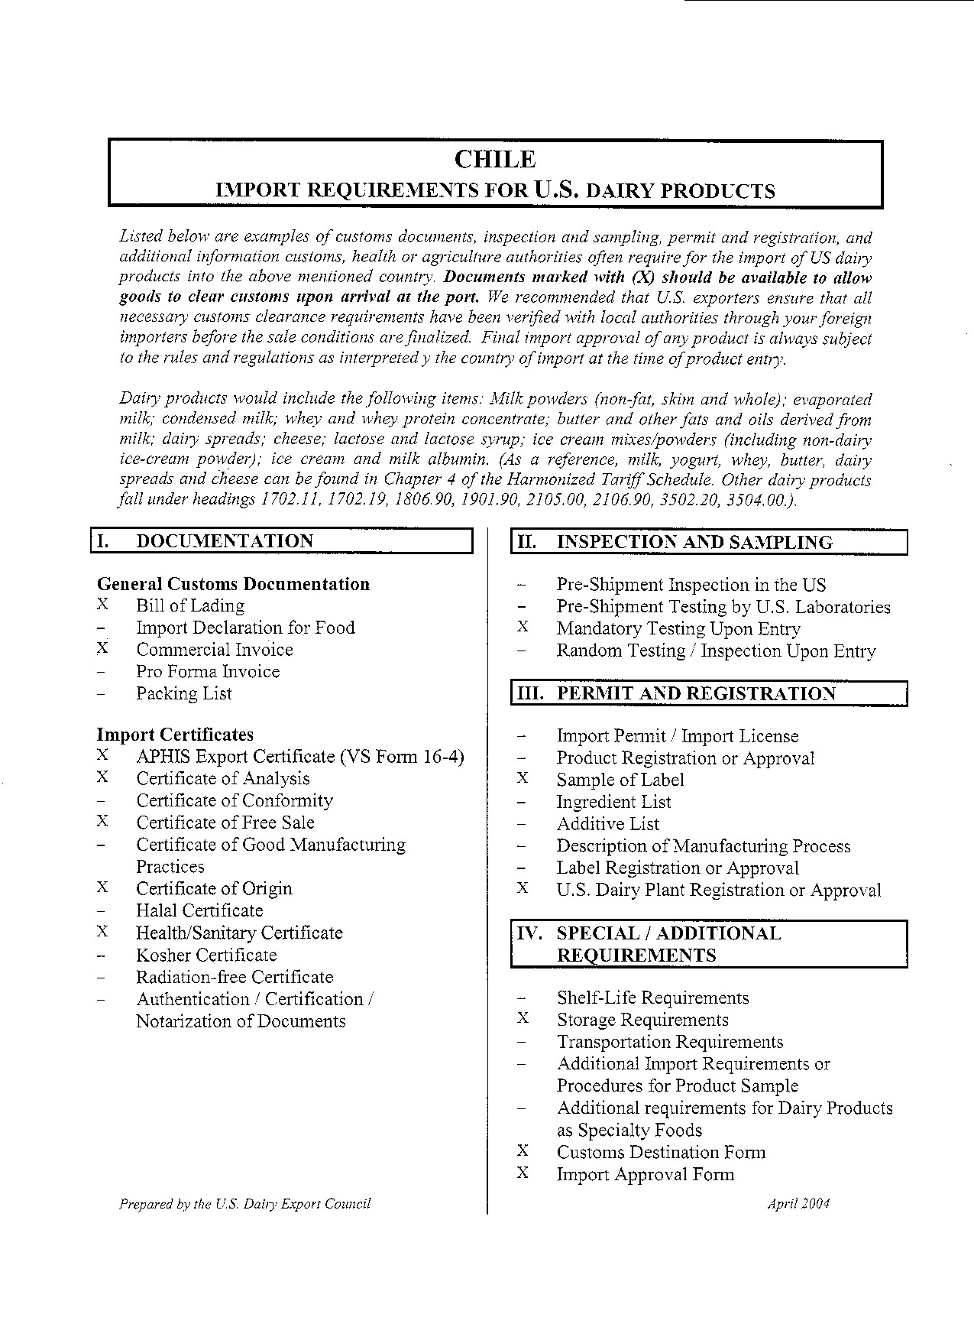
Chile

A local agent or importer is absolutely necessary to clear food products for sale and distribution in Chile. The procedure for obtaining permission to import food products begins in the Health Service Office at the port of entry. The Ministry of Health is responsible for food sanitation, including approval of food ingredients, labels, and packaging of processed foods. The Ministry is currently attempting to bring Chile’s food sanitation regulations into conformity with CODEX standards. Certificates issued in the country of origin should be completed in or translated into Spanish.

DOCUMENTATION:

Bill of Lading:
Contracts between the owner of the goods and the carrier (as with domestic shipments). There are two types. A straight bill of lading is non-negotiable. A negotiable or shipper's order bill of lading can be bought, sold, or traded while goods are in transit and is used for letter-of-credit transactions. The customer usually needs the original or a copy as proof of ownership to take possession of the goods.

Commercial Invoice:
As in a domestic transaction, the commercial invoice is a bill for the goods from the buyer to the seller. A commercial invoice should include basic information about the transaction, including a description of the goods, the address of the shipper and seller, and the delivery and payment terms. The buyer needs the invoice to prove ownership and to arrange payment. Some governments use the commercial invoice to assess customs duties.

APHIS Export Certificate (VS Form 16-4, Attachment 1):
Animal and Plant Health Inspection Service (APHIS) issues an export certificate certifying that the U.S. is free of animal diseases such as rinderpest, foot-and-mouth and contagious bovine pleuropneumonia. The certificate has space for additional declarations required by the importing country. The certificate must be signed by an authorized APHIS area veterinarian in charge of the region where the products are exported.
Additional information regarding completion of this form and location of local area veterinarians is available by contacting the APHIS National Center for Import-Export 4700 River Road, Riverdale, MD. 20737. Phone (301) 734-7885; fax (301) 734-6402.

Certificate of Analysis:
It is recommended to provide a certificate of analysis of microbiological quality and/or physical and chemical analysis for each lot number represented in the order. This certificate is generated by the manufacturer and not certified by any government authority. Consult your manufacturer for more details regarding this form.

Certificate of Free Sale:
This certificate states that the product is approved for human consumption and freely distributed in the U.S. The certificate of free sale for food products is available from both the State and Federal government.

Certificate of Origin:
Certain nations require a signed statement as to the origin of the export item. Such certificates are usually obtained through a semiofficial organization such as a local chamber of commerce. In order to receive tariff preferences through the U..S-Chile Free Trade Agreement, a Certificate of Origin must be presented to Customs.

Health/Sanitary Certificate (Attachment 2):
The USDA Agricultural Marketing Service’s (AMS) Dairy Grading Branch offers many services for exporters shipping products from USDA approved production facilities. These services are conducted on a voluntary, user fee basis. One of these services is the issuance of a Health/Sanitary Certificate. The user fee as of Jan. 1, 2002 was $56.00 per certificate. Note, this user fee is subject to change and shippers are encouraged to check with AMS to verify current prices and method of payment prior to negotiating pricing with customers. The process requires the exporter or manufacturer to complete the “Worksheet for Sanitary Certificate for Exports”; mail or fax the completed worksheet, along with the manifest, to:

Ken R. Vorgert, National Field Director
Dairy Grading Branch, Dairy Programs
Agricultural Marketing Services, USDA
Building A. Suite 370
800 Roosevelt Road
Glen Ellyn, IL 60137
Phone: 630-790-6920
Fax: 630-790-6978
AMS will issue the official certificate. The complete process takes between 3-4 business days.

INSPECTION AND SAMPLING:

Mandatory Testing:
The Health Services Office in the region where the products are being stored pulls and analyze samples. Depending on the health risk, this process can take up to 4 weeks. Upon satisfactory results, goods receive clearance for sale within the country.

PERMIT AND REGISTRATION:

U.S. Dairy Plant Registration or Approval:
On Dec. 11, 2002, the United States and Chile finalized a free trade agreement (FTA).
On January 1, 2004, the U.S.-Chile Free Trade Agreement entered into force. Though SPS issues were not technically part of the FTA negotiations, Chile also agreed to eliminate regulations requiring U.S. dairy manufacturing plants exporting to the nation to be inspected by Chilean authorities. Instead, FDA was entrusted the process of announcing the processing plants eligible to export to Chile. FDA will submit a list of the processing plants approved with the following information:

Name of the plant
Official number
Address
Identity of responsible person

This list will be posted by the Director of the Animal Protection Department (SAG) at the entry points of the country in order to allow products to be imported.

Sample of Label/Product:
As a precaution, importers introducing new products to Chile should submit samples of these products to:
Chilean Institute of Public Health
Ave. Marathon No, 1000
Santiago, Chile
Phone: 011-562-350-7477
Fax: 011-562-239-6960
Fees for sampling and conducting tests are calculated according to product weight in kilograms.

SPECIAL/ADDITIONAL REQUIREMENTS:

Storage Requirements:
The importing agent is required to provide a photocopy of the resolution certifying to the sanitary condition of the warehouse to which the products will be moved upon leaving customs.

Customs Destination Form :
(Attachment 2, Spanish; Attachment 3, English)

The importer must solicit from the Health Service at the port of entry the Customs Destination Form. The original and 5 copies are required for processing. The approval process takes up to 72 hours. Fees are assessed by weight of shipment in kilograms. Copies of the official form in Spanish and the unofficial English translated version are attached to this section. These forms are also available from the Customer Service Office of SESMA (Metropolitan Environmental Health Service), located in Av. Bulnes 194, Santiago. The general website for SESMA can be found at www.sesma.cl.

Import Approval Form:
(Attachment 4, Spanish; Attachment 5, English)

After the importer receives the approved customs destination form (see information in previous section) he must present an original and one copy of the Import Approval Form to SESMA and receive his import permit number. This permit number, including the date and name of the importer must be placed on the package. Additional labeling guidelines can be found in Volume 3 Chile General Labeling Guidelines.

Technical Product Sheet:
U.S. Embassy recommends that a technical bulletin or product sheet be provided with the documents to facility smooth trade and answer any questions that might arise with customs with regard to the use, safety or typical specifications of the product. You should consult with your importer to see if they need this type of information.

Attachments
Attachment 1: APHIS Export Certificate (VS Form 16-4).
Attachment 2: Health / sanitary certificate

Export Certificate Animal Products

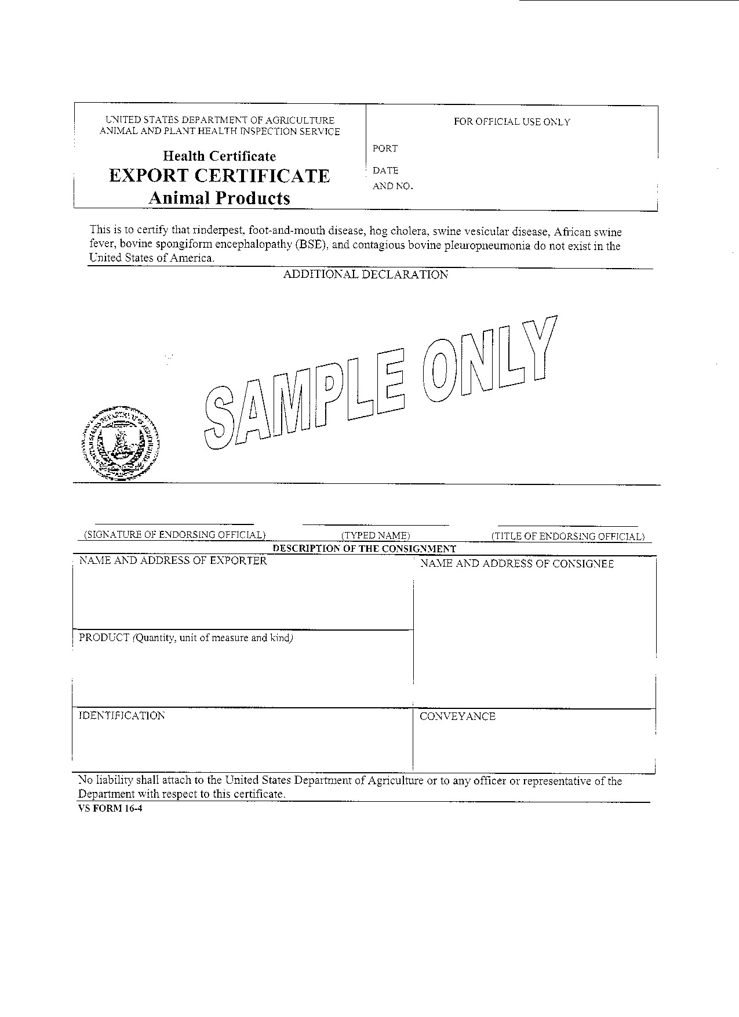

Instructions for Completition of Sanitary Certificate Worksheet for Export
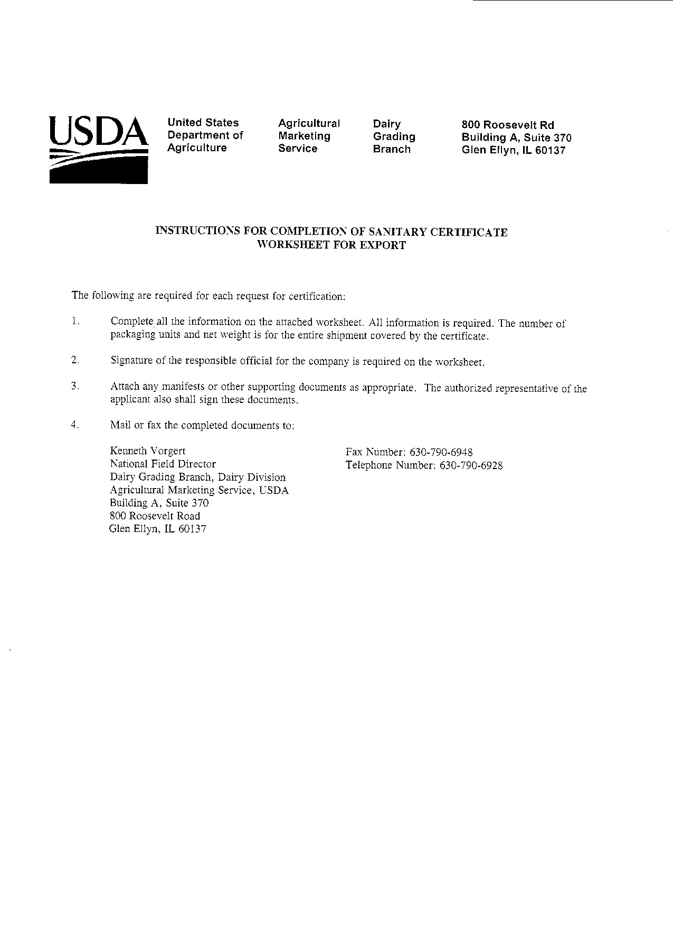

Sanitary Certificate for Exports
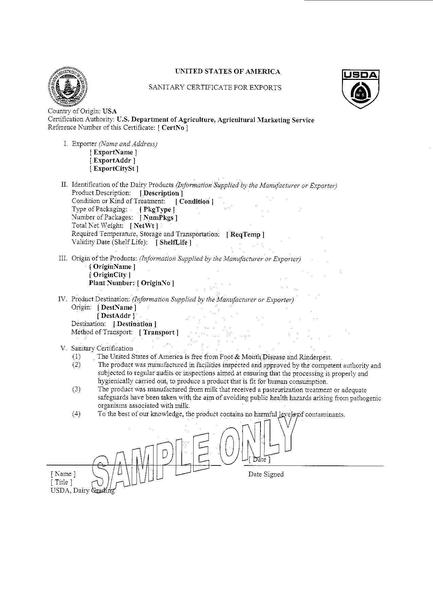

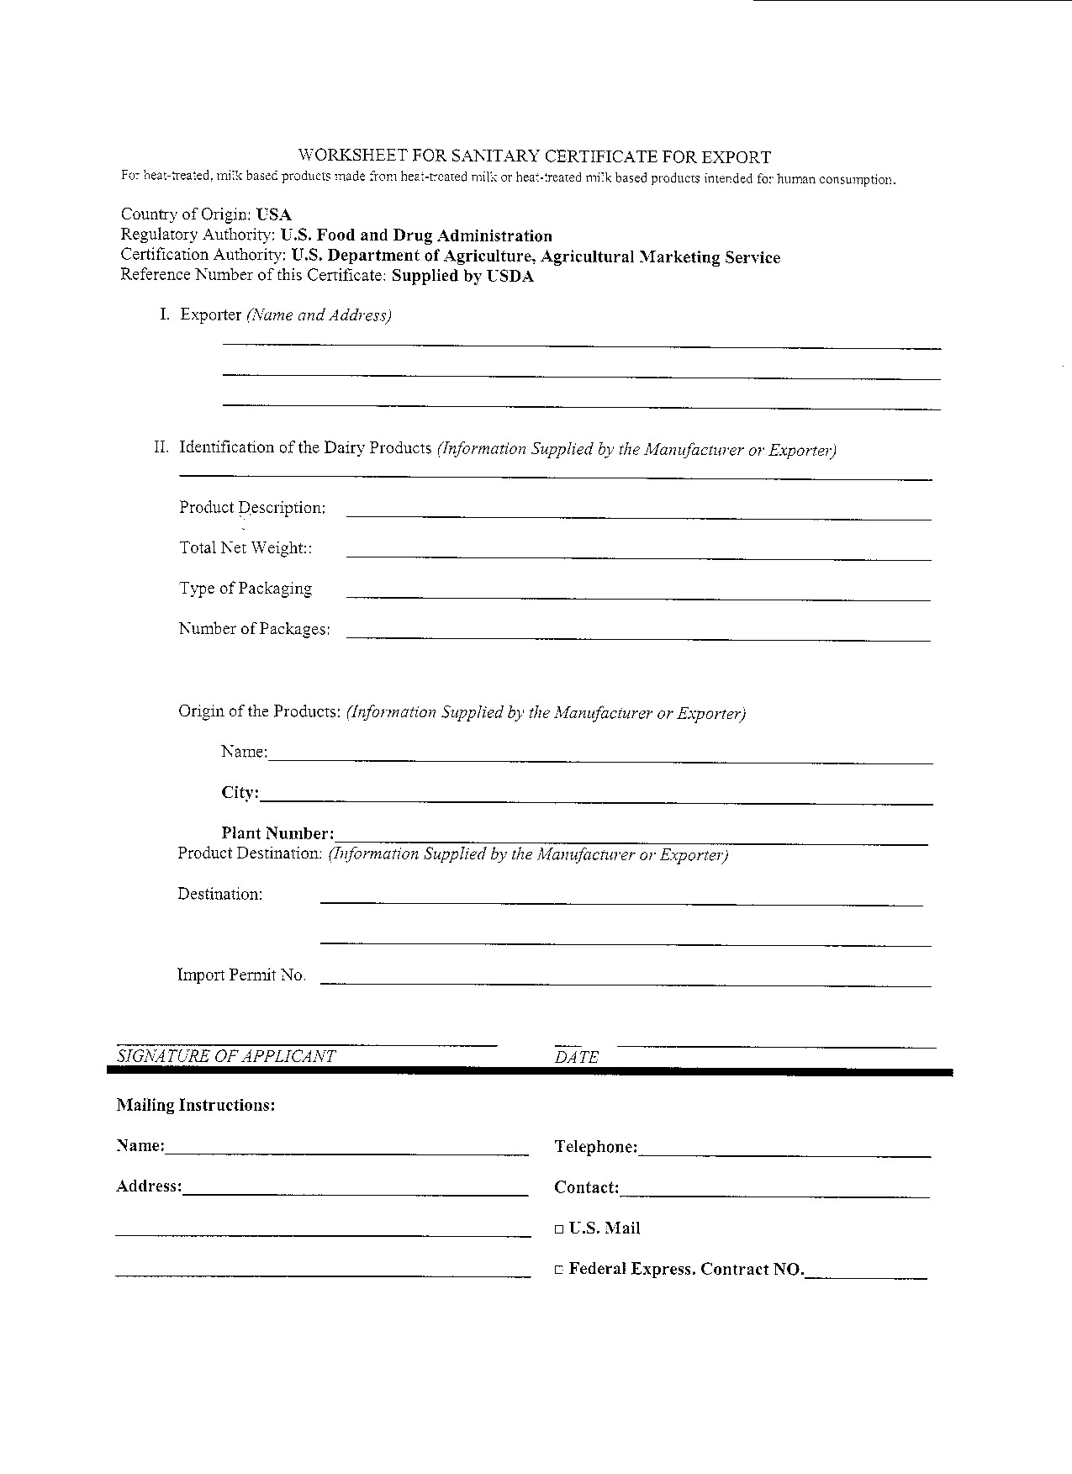

Section V. Key Contacts and Further Information

Mailing Address:
Office of Agricultural Affairs
U.S. Embassy Santiago
Unit 4118
APO AA 34033-4118

Street Address:
Office of Agricultural Affairs
Embajada de los EE.UU.
Andres Bello 2800
Las Condes
Santiago, Chile

Phone: 56-2-330-3704
Fax: 56-2-330-3203
Email: agsantiago@fas.usda.gov, fas_stgo@rdc.cl
Web Sites:
http://www.usembassy.cl; U.S. Embassy Santiago homepage. First click on “English Version” at top right and look under “Food & Agriculture”, then click on “Documents” or “Attaché Reports” for research reports, and other pages for trade leads, contacts in Chile and more,
http://www.fas.usda.gov; Foreign Agricultural Service homepage.

Annex 1. Chilean Imports of Cheese, Powdered Milk, Butter and Milk Whey, Year 2003

HS Code | Product | Value,  Total HS Code,  US$ CIF/  Metric Tons | Country of Origin | Value,  per Country,  US$CIF | Quantity,  per Country,  Tons
 |  |  | Argentina | 3,118,781 | 1,527.3
 |  |  | Germany | 427,581 | 200.7
 |  |  | New Zealand | 359,233 | 195.0
04069010 | Gouda and Gouda type | 3,957,736 | Uruguay | 49,302 | 22.4
 |  | 1,946 tons | Holland | 1,755 | 0.5
 |  |  | Brazil | 668 | 0.1
 |  |  | United States | 416 | 0.0
 |  |  | Argentina | 1,001,822 | 503.9
04061030 | Mozzarella | 1,727,461 | Brazil | 586,220 | 250.6
 |  | 826 tons | Uruguay | 139,312 | 71.2
 |  |  | Australia | 108 | 0.0
 |  |  | United States | 963,865 | 360.7
 |  |  | Australia | 64,854 | 24.3
04061020 | Cream Cheese | 1,061,875 | Brazil | 33,144 | 21.1
 |  | 406 tons | Argentina | 7 | 0.0
 |  |  | Italy | 5 | 0.0
 |  |  | France | 168,621 | 26.6
 |  |  | Holland | 139,225 | 38.5
 |  |  | Argentina | 133,768 | 49.1
 |  |  | Germany | 127,030 | 32.7
 |  |  | Uruguay | 84,896 | 26.3
04069090 | Roquefort, Camembert, | 939,544 | United States | 61,839 | 26.2
 | Gorgonzola, etc. | 255 tons | Australia | 58,506 | 17.9
 |  |  | Italy | 47,960 | 5.5
 |  |  | Spain | 43,912 | 5.9
 |  |  | Brazil | 39,619 | 16.2
 |  |  | Paraguay | 34,137 | 10.0
 |  |  | Turkey | 31 | 0.0
 |  |  | Brazil | 464,934 | 213.5
 |  |  | Argentina | 75,425 | 34.8
 |  |  | France | 73,692 | 10.4
04063000 | Processed cheese, except | 701,218 | Germany | 43,498 | 6.6
 | grated or powdered | 280 tons | Switzerland | 24,587 | 3.6
 |  |  | United States | 14,693 | 10.9
 |  |  | Spain | 2,659 | 0.1
 |  |  | Holland | 1,696 | 0.2
 |  |  | Italy | 33 | 0.0
 |  |  | Uruguay | 255,128 | 66.0
 |  |  | United States | 114,322 | 39.2
04069040 | Parmesan and Parmesan | 392,127 | Italy | 17,099 | 1.8
 | type cheese | 108 tons | Argentina | 4,255 | 0.6
 |  |  | Germany | 1,322 | 0.2
 |  |  | Brazil | 271,071 | 145.2
 |  |  | Argentina | 11,528 | 2.7
04061010 | Fresh Cheese | 283,404 | United States | 349 | 0.0
 |  | 148 tons | N.D. | 228 | 0.0
 |  |  | Taiwan | 228 | 0.1
 |  |  | Argentina | 105,008 | 39.0
 |  |  | Germany | 67,590 | 15.1
04064000 | Roquefort (blue veined) | 228,416 | France | 28,364 | 3.3
 |  | 64 tons | Denmark | 19,064 | 3.0
 |  |  | Brazil | 8,390 | 3.1
 |  |  | Australia | 138,124 | 39.0
04069020 | Cheddar and Cheddar type | 147,697 | Brazil | 9,513 | 4.8
 |  | 44 tons | Colombia | 60 | 0.0
 |  |  | Holland | 75,535 | 18.7
04069030 | Edam and Edam type | 93,218 | Germany | 9,301 | 2.0
 |  | 26 tons | Argentina | 8,356 | 5.0
 |  |  | Uruguay | 27 | 0.0
 |  |  | Uruguay | 79,709 | 16.4
04062000 | Powdered cheese | 81,036 | United States | 1,231 | 0.2
 |  | 17 tons | Argentina | 94 | 0.0
 |  |  | Italy | 2 | 0.0
04061090 | The other fresh cheeses | 28,796 | France | 12,700 | 1.2
 | (not fermented) including | 10 tons | Brazil | 9,415 | 6.2
 | whey cheese and curd. |  | Argentina | 6,681 | 2.4
 |  |  | Uruguay | 6,468,291 | 3,761.3
 |  |  | Argentina | 4,144,514 | 2,343.1
 |  |  | Canada | 2,876,262 | 1,703.6
04021000 | Powdered Milk, fat content | 14,999,849 | Germany | 498,608 | 288.0
 | not exceeding 1.5% | 8,692 tons | England | 354,184 | 208.0
 |  |  | Denmark | 346,763 | 204.0
 |  |  | Ireland | 203,993 | 112.0
 |  |  | New Zealand | 107,234 | 71.6
 |  |  | Argentina | 16,614,664 | 8,934.7
 |  |  | Uruguay | 6,289,291 | 3,450.7
 |  |  | Ireland | 2,183,428 | 1,244.0
 |  |  | Belgium | 1,642,872 | 948.6
04022118 | Powder Milk, fat content | 28,284,058 | Denmark | 952,933 | 616.2
 | exceeding 26% | 15,539 tons | Holland | 340,098 | 200.0
 |  |  | Canada | 88,804 | 48.0
 |  |  | France | 83,846 | 46.0
 |  |  | Brazil | 48,333 | 25.0
 |  |  | New Zealand | 39,789 | 25.2
 |  |  | Uruguay | 2,427,325 | 1,567.5
 |  |  | Australia | 1,385,591 | 944.0
 |  |  | New Zealand | 476,549 | 267.0
04051000 | Butter | 4,528,503 | Argentina | 198,304 | 125.0
 |  | 2,925 tons | Ireland | 36,860 | 19.0
 |  |  | United States | 2,644 | 1.9
 |  |  | Holland | 1,127 | 0.5
 |  |  | Belgium | 103 | 0.0
 |  |  | Argentina | 2,791,042 | 1,682.3
 |  |  | France | 906,692 | 1,317.2
 |  |  | United States | 706,346 | 1,306.7
 |  |  | New Zealand | 510,874 | 210.1
 |  |  | Holland | 332,290 | 365.2
 |  |  | Finland | 192,069 | 238.0
04040000 | Milk Whey | 5,599,763 | Uruguay | 96,169 | 140.0
 |  | 5,307 tons | Germany | 48,859 | 26.0
 |  |  | Canada | 6,153 | 20.0
 |  |  | South Africa | 5,797 | 1.0
 |  |  | Brazil | 3,218 | 0.4
 |  |  | Belgium | 165 | 0.0
 |  |  | Israel | 89 | 0.0

Annex 2. Imports of Cheese, Powdered Milk, Butter and Whey, 1999-2003, Thousands of US$ CIF

 |  | 1999 | 2000 | 2001 | 2002 | 2003 | 2003
HS Code | Product | US$ x 1,000 |  |  |  |  | M. Tons
04060000 | Total Cheeses | 8,783.4 | 14,900.1 | 7,750.6 | 7,145.6 | 9,642.5 | 4,128.0
04061000 | Cheese, fresh (including whey cheese), not fermented, and curd | 841.4 | 873.2 | 1,744.0 | - | - | -
04061010 | Fresh Cheese | - | - | - | 115.2 | 283.4 | 148.0
04061020 | Cream Cheese | - | - | - | 469.6 | 1,061.9 | 406.1
04061030 | Mozzarella | - | - | - | 1,117.8 | 1,727.5 | 825.7
04061090 | The other fresh cheese (not fermented) including whey cheese and curd. | - | - | - | 15.9 | 28.8 | 9.8
04062000 | Powdered cheese | 219.5 | 114.9 | 202.9 | 99.9 | 81.0 | 16.6
04063000 | Processed cheese, except grated or powdered | 464.1 | 619.5 | 861.9 | 731.4 | 701.2 | 280.2
04064000 | Roquefort (blue-veined) | 230.1 | 276.8 | 213.7 | 191.9 | 228.4 | 63.5
04069000 | The other cheeses | 7,028.4 | 13,015.8 | 4,728.1 | - | - | -
04069010 | Gouda and Gouda type | - | - | - | 2,755.1 | 3,957.7 | 1,946.1
04069020 | Cheddar and cheddar type | - | - | - | 139.8 | 147.7 | 43.8
04069030 | Edam and Edam type | - | - | - | 63.1 | 93.2 | 25.6
04069040 | Parmesan and Parmesan type cheese | - | - | - | 122.5 | 392.1 | 107.8
04069090 | Roquefort, Camembert, Gorgonzola | - | - | - | 1,323.5 | 939.5 | 254.8
04021000 | Powdered Milk, fat content not exceeding 1.5% | 13,427.3 | 16,705.3 | 12,428.9 | 7,807.3 | 14,999.8 | 8,692
04022118 | Powder Milk, fat content exceeding 26% | 4,387.0 | 13,401.3 | 9,064.1 | 3,093.1 | 28,284.0 | 15,539
04051000 | Butter | 1,075.6 | 2,887.4 | 1,463.5 | 622.6 | 4,528.5 | 2,925
04040000 | Milk Whey | 1,308.2 | 2,765.1 | 3,324.8 | 1,826.5 | 5,599.7 | 5,307
Note: Some HS codes were subdivided in 2002. Dashes mean no data for those codes after 2001 and no data for subdivided codes before 2002.

